A SEMINAR:
GOING DEEPER
IN THE WORD

COLVILLE CHURCH OF GOD
760 East Columbia Ave Colville, WA 99114
509-684-5551

“The true beauty of a Scripture passage does not lie on the surface,
nor reveal itself to a careless eye.
A fragment of spar, which at first seemed lusterless and unattractive,
as you turn it in your hand, and let the light strike it at a certain angle,
reveals beautiful radiance and even prismatic colors.

A fragment of Scripture, which is comparatively dull and dead to a superficial reader,
becomes in the hand of a devout student, a marvel of beauty.
He turns it round and round, views it at every angle,
till he sees the light of God break through it,
and it shines with the sevenfold beauty of the Divine attributes.”
A.T. Pierson, The Key Words of the Bible, pg.v.

PRESENTED BY
REV. DR. JOY KARANICK ROACH

GOALS AND OBJECTIVES

GOAL

To disseminate a systematic approach to
study of the Word of God utilizing the principles and tools
of Exegesis and Hermeneutics

OBJECTIVES

Upon completion of this seminar the participant will be able to:

- Define exegesis, hermeneutics, and homiletics
- Define metaphor, simile, and parable. Give one example of each
- State the four pillars to bridge understanding of Biblical Interpretation
- Discuss at least three hermeneutical principles of Biblical Interpretation
- Outline the methodology taught in Biblical Interpretation according to the chart provided
- Distinguish between the Northern and Southern kingdoms of Israel
- Discuss various resources and tools for exegetical and hermeneutical purposes
- Define the hours and the watches of the day
- Explain 2 of the Jewish Feast and how they pre-figure Jesus
- Explain how to use the Jewish Calendar and state its importance to Biblical Interpretation
- Explain the meaning of the Babylonian Captivity
- State 3 words for Praise or Worship in the Old and New Testament and their meaning

TABLE OF CONTENTS

INTRODUCTION 4
DEFINITIONS 5
BIBLICAL INTERPRETATION MODEL 6
FOUR PILLARS: BRIDGE TO UNDERSTANDING 7
THE GAPS 8-26
LANGUAGE 9-15
CULTURE 16
HISTORY 17-25
GEOGRAPHY 26
THE PRINCIPLES 40-46
THE CONTEXT PRINCIPLE 41-42
THE FIRST MENTION PRINCIPLE 43
THE COMPARATIVE MENTION PRINCIPLE 43
THE PROGRESSIVE MENTION PRINCIPLE 44
THE COMPLETE MENTION PRINCIPLE 45
THE CHRISTO-CENTRIC PRINCIPLE 45
THE SYMBOLIC PRINCIPLE 46-63
THE NUMERICAL PRINCIPLE 64
THE TYPICAL PRINCIPLE 65
MISCELLANEOUS TOOLS FOR BIBLICAL INTERPRETATION 66-94
HOURS AND WATCHES 67
TIMES AND SEASONS OF THE BIBLE 68
JEWISH CALENDAR 69
JEWISH FEASTS AND FESTIVALS 70
MEASURES AND MONEY 71-72
COMPARISON LISTS IN OT BOOKS 73
THE BIBLE IS ORGANIZED 74
PSALMS 75-76
SALVATION 77-87
JESUS IS GOD 88-94
USEFUL RESOURCES 95
CLASS EVALUATION 96
INTRODUCTION

The Bible is one of the main ways God uses to speak to His people. Yet, many find it difficult to study and understand. The Bible is so rich that it would take more than a lifetime to grasp its fullness. We can only realize the complete fullness of the Word when we get to heaven and see Jesus. However, by using a methodical and more informed approach to examine the text we can go deeper.

We are commanded to study the Word of God.

Second Timothy 2:15
Be diligent to present yourself approved to God, a worker who does not need to be ashamed, rightly dividing the word of truth.

The word “study” used here, in the Greek, means “to give diligence to” The words “rightly dividing” mean, in the Greek, to cut straight, to make straight and to handle aright, to teach the truth directly and correctly”.

WHY STUDY?
We are directed to give diligence to study of the Word so that we can handle it appropriately and teach it to others.

I Timothy 4:1
Now the Spirit expressly says that in latter times some will depart from the faith, giving heed to deceiving spirits and doctrines of demons

It is never acceptable for the Christian to neglect the study of the Word, certainly now in this age, it is far more dangerous. As we enter the end times the perils of spiritual warfare are upon us. First Timothy 4:1 teaches us that in the latter (end) times some will leave the faith.
The enemy can easily trick us if we do not know God’s Word for ourselves. There may be no Pastor to preach or teach us in the last days. We will find ourselves giving into various forms of religious beliefs and traditions instead of having a true understanding of what the Bible really says if we don’t know the Truth. The Word of God is what grounds us in faith.

DEFINITIONS

1. HERMENUTICS
Biblical hermeneutics is the study of the principles of interpretation of the Bible.
(The Principles)

Theories or science of interpretation

The branch of knowledge that deals with interpretation, especially of the Bible or literary texts

The guidelines

The philosophy of text interpretation

2. EXEGESIS
Bringing out the meaning of the text- to search for explanation
(The Research)

The critical explanation or interpretation of a text, especially of scripture

The interpreter is led to his conclusions by following the text

The process of uncovering the literal meaning of a text

To make sense of what the text meant to the original, historical audience and how it applies to today’s hearer and reader

3. HOMILETICS
The art of preaching and/or writing sermons
(The Delivery)

DIFFERENT THAN EXEGESIS

The terms hermeneutics and exegesis are often used interchangeably, yet there is a distinction to be made.

Bernard Ramm (1916-1992), a Baptist Theologian, describes the difference as follows:
"Hermeneutics . . . stands in the same relationship to exegesis that a rule-book stands to a game. . . . The rules are not the game, and the game is meaningless without the rules. Hermeneutics proper is not exegesis, but exegesis is applied hermeneutics." Perhaps the closest relation between these two terms would be "hermeneutics" and "exegetical method."

BIBLICAL INTERPRETATION MODEL

2.MEDITATE (PRAY) AND ASK QUESTIONS

Who is speaking?
Who is the audience?
When was this written?
What type of genre is it?
What is the purpose of the text?
What does it mean?
How would the original hearer interpret the text?

1.

READ 3-4 times and compare with other translations

3.PONDER THE PRINCIPLES OF HERMENUTICS

Context Principle
First Mention Principle
Comparative Mention Principle
Complete Mention Principle
Chronometrical Principe
Christo-Centric Principle
Symbolic Principle
Numerical Principle
Typical Principle
Parabolic Principle
Allegoric Principle

4.EXEGETE THE TEXT

Consider the four pillars to strengthen the bridge of understanding

LANGUAGE
CULTURAL
HISTORICAL
GEOGRAPHICAL

5. PERFORM HOMILETICS

Prepare to preach the sermon
Write out the outline and sermon
Avoid the don’ts of public speaking
Communicate the Good News in a way that people want to listen

TOPICAL
TEXTUAL
EXPOSITORY

FOUR PILLARS: BRIDGE TO UNDERSTANDING

WHY DO WE EXEGETE?
TO CLOSE THE GAPS
TO HEAR AS THE ORIGINAL HEARER
TO UNDERSTAND THE INTENT OF THE ORIGINAL AUTHOR

LANGUAGE  Concordance  Theological Wordbooks  Expository Dictionaries  Biblical Dictionaries | CULTURAL  Manner and Customs of Biblical Times  Life in Biblical Israel  Dictionary of Bible Life and Times  Encyclopedia of Bible Facts
HISTORICAL  History of Israel  Christian History  Bible Handbooks  Bible Commentaries | GEOGRAPHICAL  Atlas  Maps and Charts
PREPARED BY REV. DR. JOY KARANICK ROACH

THE GAPS

- LANGUAGE
- Focus
- The Bible's 66 books – 39 in the Old Testament and 27 in the New Testament – are written across 3 continents of Asia, Africa, and Europe, written by 40 different authors from various walks of life over a period of 1,500 years!
- The Bible was written in 3 languages. The Old Testament was written primarily in Hebrew and the New Testament was written in Greek. The Aramaic language is represented in a small portion of the Bible.

  - The portions of Scripture that were written in Aramaic include Ezra 4:8–6:18and 7:12-26 (67 verses), Daniel 2:4b–7:28 (200 verses), Jeremiah 10:11, and various proper names and single words and phrases scattered throughout the Old and New Testaments.
(https://truthonlybible.com/2015/11/23/aramaic-the-bibles-third-language/)
- Talitha cum meaning “Little girl, get up!” (Mark 5:41)
Ephphatha meaning “Be opened.” (Mark 7:34)
Abba meaning “Father” (Mark 14:36)
Raca meaning “fool” (Matthew 5:22)
Rabbouni meaning “teacher” (John 20:16)
Eli Eli lema sabachthani meaning “My God, my God, why have you forsaken me?” (Matthew 27:46)
Hosanna meaning “O Lord, save us.” (Mark 11:9)
Maranatha meaning “Lord, come!” (1 Corinthians 16:22)
( https://bustedhalo.com/ministry-resources/what-verses-in-the-new-testament-are-aramaic)
- While translations are remarkedly close to the original meaning, the subtleties and the nuance of a word or phrase may be lost in the translation The way we speak often changes from times past. The English we speak today is far from the Old English of yesteryear. Therefore, we need to know how to close the language gap from the original author to the current day reader.

- Resources
- Strong’s Exhaustive Concordance
- Vine’s Dictionary
- Theological Wordbooks
- Theological Dictionaries
- Lexicons
- Biblical Dictionaries
- Figures of Speech

- Examples
- Jeremiah 48:11 C/P Isaiah 51:17, 51:22 Dregs-lees “SHEH’MER”; QUBBA’ATH
- Psalms 37:4 Delight “AWNAG”
- Matthew 5:18 Jot and Tittle (yod- smallest letter and stroke smaller
than yod)
- Psalms 111:1 Praise the Lord/Halleluyah
- Matthew 7:12; Matthew 22:40; Romans 3:21 Law and Prophets TaNaKh
                - Torah (The Five Books of Moses) & Nevi'im (Prophets)
& Ketuvim (Writings
- Genesis 22:14 Jehovah Jireh
- Genesis 1:28 Replenish “MAW-LAY”
- 1 Kings 17:3,5 Cherith
- 1Kings 17:10 Zarephath
- Jeremiah 1:12 Hasten
- Ruth Return/Schoov
  - 1:6 return
  - 1:7 return
  - 1:8 return
  - 1:10 return
  - 1:11 turn again
  - 1:12 turn again
  - 1:15 gone back and return X2
  - 1:16 return
  - 1:21 home again
  - 1:22 returned X2
__________________
  - 4:3 has come again
  - 4:15 a restorer

- Practice
- Look up words using Strong’s or an application
- Perform a word study for Praise and Worship

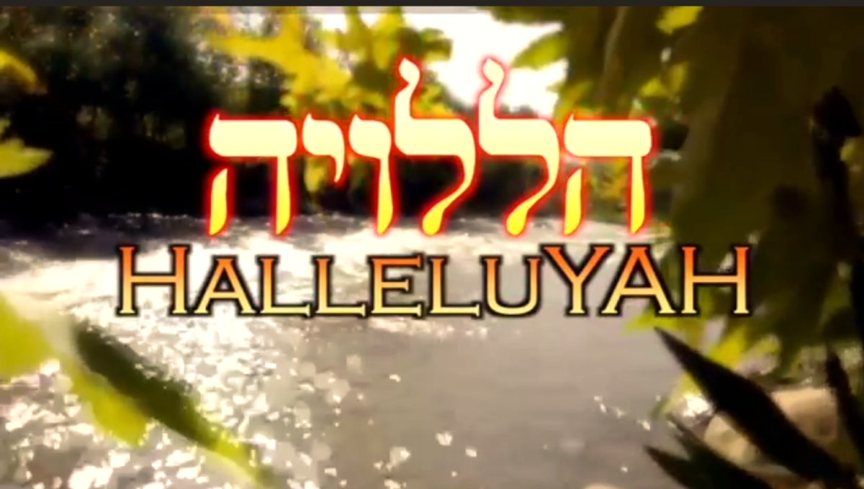

“In Hebrew, the word we derive our song of praise from is "Halleluyah," the root word of which is "halal," meaning "to praise or extol the greatness of someone," combined with "Yah," which is a shortened form of God's name, Yahweh. Most scholars agree that the first time "Hallelujah" is mentioned is in Psalm 104:35:”

https://www.christianity.com/wiki/christian-terms/what-is-the-meaning-of-hallelujah-in-the-bible.html#google_vignet
FIGURES OF SPEECH IN THE BIBLE

1.Metaphor- a figure of speech in which a term or phrase is applied to something to which it is not literally applicable in order to suggest a resemblance, as in “A mighty fortress is our God.”.
something used, or regarded as being used, to represent something else; emblem; symbol.
An implied comparison between two objects without the use of "like" or "as".

Examples of metaphors for God
Father Dt 32:6; Isa 64:8; Mal 2:10; Eph 4:6
Rock Dt 32:4 See also 1Sa 2:2; 2Sa 22:2; Ps 62:2; Ps 78:35
Shepherd Ps 23:1 See also Ps 28:9; Ps 80:1; Eze 34:11-16

Examples of metaphors for Jesus Christ
Bread of life Jn 6:35-51
Good shepherd Jn 10:11,14
Light of the world Jn 8:12; Jn 9:5

Examples of metaphors for the Holy Spirit
Counsellor Jn 14:16,26; Jn 15:26; Jn 16:7
Breath Ge 2:7; Job 32:8; Job 33:4; Job 34:14
Wind Jn 3:8

2.Simile- a figure of speech in which two unlike things are explicitly compared, as in “she is like a rose.” A common figure of speech that explicitly compares two things usually considered different. The likening of one thing to another. similes are introduced by like or as.
Examples
They came up with their livestock and their tents like swarms of locusts Judges 6:5
The kingdom of heaven is like treasure hidden in a field. Matt. 13:44

3. Allegory- a representation of an abstract or spiritual meaning through concrete or material forms; figurative treatment of one subject under the guise of another. A story that has a deeper or more general meaning in addition to its surface meaning. Allegories are composed of several symbols or metaphors.
Example
Allegory of DAMASCUS
Based on Isaiah 17 record of Damascus (capital city of Syria) becoming a "ruinous heap", and how Saul of Tarsus was on that road, intent on persecuting Christians, when he was interrupted by that Great Light (the Bible) and the voice of Jesus, when others thought it was thunder. In this allegory we're ALL traveling the Road to Damascus and/or sailing the Sea of Life.

4. Symbolism- the practice of representing things by symbols, or of investing things with a symbolic meaning or character. The use of any of certain special figures or marks of identification to signify a religious message or divine being, as the cross for Christ and the Christian faith.
Examples
Door Opportunity, Freedom, Power Matthew 25:10, Acts 14:27;
1Corinthians 16:9, Colossians 4:3
Oil Prosperity Deuteronomy 32:13, 33:24, 2Kings 18:32
Rain Something refreshing, delightful Psalm 68:9; Isaiah 5:6
Throne Kingdom, seat of government Psalm 122:5; Daniel 7:9

FIGURES OF SPEECH IN THE BIBLE

5. Parable- a short allegorical story designed to illustrate or teach some truth, religious principle, or moral lesson. A statement or comment that conveys a meaning indirectly by the use of comparison, analogy, or the like.
Example
The Prodigal Son Luke 15: 11-32
The Ten Lepers Luke 17: 11-19

6. Hyperbole- an exaggeration to make or reinforce a point
Example
"...it is easier for an camel to go through the eye of needle than for a rich man to enter the kingdom of God.". Matt. 19:24 (Mark 10:25; Luke 18:25)

7. Hendiadys- The combination of two or three things to express the same meaning
Example
The Lord is my light and my salvation –
whom shall I fear?
The Lord is the stronghold of my life -
of whom shall I be afraid? Psalm 27:1

8. Irony- Stating one thing while meaning the exact opposite
Example
Go and cry out to the gods you have chosen. Let them save you when you are in trouble! Judges 10:14)

9. Litotes or Meiosis- a phrase that understates or lessens one thing in order to magnify another
Example
For I am the least of all the apostles and do not even deserve to be called an apostle, because I persecuted the church of God. But by the grace of God I am what I am, and his grace to me was not without effect…
1 Cor. 15:9-10

10. Antithesis- A direct contrast in which two sets of figures are set in opposition to one another.
Antithesis means opposite and is used as a literary device to put two contrasting ideas together.
Example
For the wages of sin is death; but the gift of God is eternal life through Jesus Christ our Lord
Rom. 6: 23.
Matthew 5 (six antithesis — You have heard it said do not…but I say unto you….)

Sources:
http://www.biblicalstudies.org.uk/ (Robert I Bradshaw)
http://dictionary.reference.com/
https://www.biblegateway.com/resources/dictionary-of-bible-themes/5409-metaphor
http://usingthebible.blogspot.com/2008/05/simile-and-metaphor.html
http://www.cswnet.com/~tracie/Allegory.htm

WORD: DELIGHT

# | STRONG’S # | SCRIPTURE | DEFINITION | COMMENTS
1 | 2654 | GEN 34:19  NUM 14:8  DT 10:15  DT 21:14  1 SAM 18:22  I SAM 15:26  2 SAM 24:3  EST 6:6  PS 40:8;68:30
2 | 2656 | 1 SAM15:22  PS 1:2  PS 16:3
3 | 6026 | JOB 22:26  JOB 27:10  PS 37:4  PS 37:11  IS 55:2  IS 58:14  IS 66:11
4 | 7521 | PS 62:4
5 | 8173 | PS 94:19  PS 119:16

WORD: ____________________

# | STRONG’S # | SCRIPTURE | DEFINITION | COMMENTS
1
2

3
4
5

HEBREW LETTERS AND NUMBERS

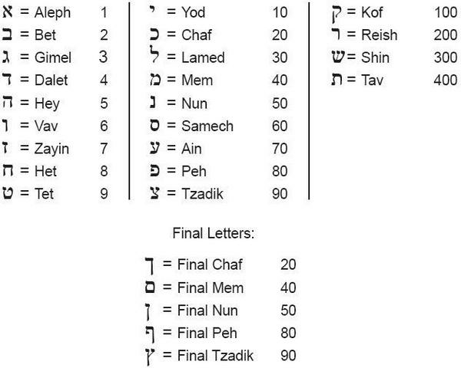

WORD STUDY ON PRAISE AND WORSHIP

PRAISE
OLD AND NEW TESTAMENT
# | OT WORD FOR PRAISE | STRONG’S NUMBER | DEFINITION | SCRIPTURE
1 | Hâlal ( הָלַל )  verb | 1984 | “to praise, celebrate, glory, sing (praise), boast.” The meaning “to praise” is actually the meaning of the intensive form of the Hebrew verb hâlal, which in its simple active form means “to boast.” In this latter sense hâlal is found in its cognate forms in ancient Akkadian, of which Babylonian and Assyrian are dialects. The word is found in Ugaritic in the sense of “shouting,” and perhaps “jubilation.” Found times in the Old Testament, hâlal is used for the first time in Gen. 12:15, where it is noted that because of Sarah’s great beauty, the princes of Pharaoh “praised” (KJV, “commended”) her to Pharaoh.  While hâlal is often used simply to indicate “praise” of people, including the king (2 Chron. 23:12) or the beauty of Absalom (2 Sam. 14:25), the word is usually used in reference to the “praise” of God. Indeed, not only all living things but all created things, including the sun and moon, are called upon “to praise” God (Ps. 148:2-5, 13; 150:1). Typically, such “praise” is called for and expressed in the sanctuary, especially in times of special festivals (Isa. 62:9).  The word hâlal is the source of “Hallelujah,” a Hebrew expression of “praise” to God which has been taken over into virtually every language of mankind. The Hebrew “Hallelujah” is generally translated “Praise the Lord!” The Hebrew term is more technically translated “Let us praise Yah,” the term “Yah” being a shortened form of “Yahweh,” (IMPERITIVE)  Crazy exuberant praise. | Gen 12:15  Psalms 111:1  Ezra 3:10-11  Psalms 18:3  Psalms 35:18  Ecclesiastes 2:2  Ecclesiastes 7:7
2 | Yâdâh (יָדָה)  verb | 3034 | “to give thanks, laud, praise.” A common Hebrew word in all its periods, this verb is an important word in the language of worship.  Yâdâh is found nearly 120 times in the Hebrew Bible, the first time being in the story of the birth of Judah, Jacob’s son who was born to Leah: “And she conceived again and bore a son, and said, This time I will praise the Lord; therefore she called his name Judah” (Gen. 29:35, RSV).  As is to be expected, this word is found most frequently in the Book of Psalms (some 70 times). As an expression of thanks or praise, it is a natural part of ritual or public worship as well as personal praise to God (Ps. 30:9, 12; 35:18). Thanks often are directed to the name of the Lord (Ps. 106:47; 122:4).  To praise with extended hands  To revere or worship with extended hands | Leviticus 5:5  Leviticus 16:21  Leviticus 26:40  2 Samuel 22:50  1 Kings 8:33,35  Psalms 7:17  Psalms 9:1

3 | Tehillâh (תְּהִלָּה)  noun | 8416 | “glory; praise; song of praise; praiseworthy deeds.” Tehillâh occurs 57 times and in all periods of biblical Hebrew.  First, this word denotes a quality or attribute of some person or thing, “glory or praiseworthiness”: “He is thy praise, and he is thy God, that hath done for thee these great and terrible things, which thine eyes have seen” (Deut. 10:21). Israel is God’s “glory” when she exists in a divinely exalted and blessed state: “And give him no rest, till he establish, and till he make Jerusalem a praise in the earth” (Isa. 62:7; cf. Jer. 13:11).  Second, in some cases tehillâh represents the words or song by which God is publicly lauded, or by which His “glory” is publicly declared: “My praise [the Messiah is speaking here] shall be of thee in the great congregation …” (Ps. 22:25). Ps. 22:22 is even clearer: “I will declare thy name unto my brethren: in the midst of the congregation will I praise thee.”  In a third nuance tehillâh is a technical-musical term for a song (shir) which exalts or praises God: “David’s psalm of praise” (heading for Ps. 145; v. 1 in the Hebrew). Perhaps Neh. 11:17 refers to a choirmaster or one who conducts such singing of “praises”: “And Mattaniah … , the son of Asaph, was the principal to begin the thanksgiving in prayer [who at the beginning was the leader of praise at prayer].…”  Finally, tehillâh may represent deeds which are worthy of “praise,” or deeds for which the doer deserves “praise and glory.” This meaning is in the word’s first biblical appearance: “Who is like unto thee, O Lord, among the gods? Who is like thee, glorious in holiness, fearful in praises [in praiseworthy deeds], doing wonders [miracles]?” (Exod. 15:11).  Two other related nouns are mahalal and hillulim. Mahalal occurs once (Prov. 27:21) and denotes the degree of “praise” or its lack. Hillulim, which occurs twice, means “festal jubilation” in the fourth year at harvest time (Lev. 19:24, RSV; Judg. 9:27, NASB)
4 | Tôdâh (תּוֹדָה)  noun | 8426 | “thanksgiving.”  This important noun form, found some 32 times in the Old Testament, is used there in the sense of “thanksgiving.” The word is preserved in modern Hebrew as the regular word for “thanks.” In the Hebrew text tôdâh is used to indicate “thanksgiving” in songs of worship (Ps. 26:7; 42:4). Sometimes the word is used to refer to the thanksgiving choir or procession (Neh. 12:31, 38). One of the peace offerings, or “sacrifices,” was designated the thanksgiving offering (Lev. 7:12). | Psalms 50:23  Psalms 95:2  Psalms 50:14
5 | Barak  verb | 1288 | ‘Barak’ means to bless, to kneel, or bow down in worship. This word is the most used word of all the words for praise in the Old Testament. Even more than ‘Halal’, the word we get Hallelujah from!  Adoration overlaps with praise in its meaning  to kneel down, to bless God as an act of adoration  To kneel in reverence and submission | Psalms 34:1  Psalms 95:6  1 Chronicles 29:20  Psalm 103:1-2,20-22}
6 | Zamar  verb | 2167 | To make music- of singing or playing musical instruments  Means to praise using the music and its instruments.  Referred to as praising God by using music to express our adoration, may it be accompanied by instruments or even with our own voice.  Just like in Psalm 108:1,3, “O God, my heart is fixed. I will sing and give praise (zamar), even with my glory. I will praise (yadah) Thee, O LORD, among the people: and I will sing praises (tehillah) unto Thee among the nations.” | Judges 5:3  Psalms 18:49  Psalms 147:1  Psalms 108:1,3  Ps.144:9
7 | Shabach  Verb | 7623 | Giving a loud shout- to address in a loud voice  To soothe, still, stroke,to laud praise, to commend, to boast | Psalms 63:3  Psalms 65:7  Psalms 145:4  Psalms 89:9  Psalms 106:47

https://www.studylight.org/dictionaries/eng/vot/p/praise.html
https://studyingprayer.com/2012/07/12/hebrew-words-for-praise-barak/
https://getgodtoday.com/2021/10/30/a-hebrew-word-for-praise-barak/
https://godtv.com/zamar-the-hebrew-word-for-praising-god-with-music/
https://biblehub.com/hebrew/2167.htm

# | NT WORD FOR PRAISE | STRONG’S NUMBER | DEFINITION | SCRIPTURE
1. | Ainos  Noun | 136 | A saying, a proverb, a tale, a narration, praise, laudatory discourse, properly a story | Matthew 21:16  Luke 18:43
2 | Epainos | 1868 | "approbation, commendation, praise;" it is used (a) of those on account of, and by reason of, whom as God's heritage, "praise" is to be ascibed to God, in respect of His glory (the exhibition of His character and operations) | Romans 2:29  Ephesians 1:6,12,14  1Corinthians 4:5  Philippians 1:11; 4:8
3. | Ainesis  Noun | 133 | Praise, a thanks offering | Hebrew 13:15
4. | Aineo  Verb | 134 | To praise, extol, to sing praises in honor to God, to vow, to promise | Rev 19:5
5. | Doxa  Noun | 1391 | Opinion, judgment, view, splendour, brightness of the moon, sun, starts, majesty, most exhalted state | 1 Peter 4:11
6. | Epaineo  Verb | 1867 | To approve, to praise, to applaud, commend, laud | 1 Corinthians 11:2,17,22,
7. | Humneo  Verb | 5214 | To sing the praise of, sing hymns to | Matthew 26:30  Mark 14:26  Acts 16:25  Hebrews 2:12
8. | Psallo  Verb | 5567 | To twitch, twang, (as a bowstring) to play a stringed instrument with the fingers  To pluck off, to pull out, to touch or strike the chord | Romans 15:9  1 Corinthians 14:15  Ephesians 5:19  James 5:13
9. | Exomologeo  Verb | 1843 | To confess, to profess, acknowledge openly and joyfully, to celebrate,to promise, agree | Romans 15:9

https://bibleportal.com/dictionary/vine-s-expository-dictionary-of-nt-words/praise
Strong’s Exhaustive Concordance

WORSHIP
OLD AND NEW TESTAMENT

# | OT WORD FOR WORSHIP | STRONG’S NUMBER | DEFINITION | SCRIPTURE
1 | Shâchâh (שָׁחָה) | 7812 | “to worship, prostrate oneself, bow down.” This word is found in modern Hebrew in the sense of “to bow or stoop,” but not in the general sense of “to worship.” The fact that it is found more than 170 times in the Hebrew Bible shows something of its cultural significance. It is found for the first time in Gen. 18:2, where Abraham “bowed himself toward the ground” before the 3 messengers who announced that Sarah would have a son.  The act of bowing down in homage is generally done before a superior or a ruler. Thus, David “bowed” himself before Saul (1 Sam. 24:8). Sometimes it is a social or economic superior to whom one bows, as when Ruth “bowed” to the ground before Boaz (Ruth 2:10). In a dream, Joseph saw the sheaves of his brothers “bowing down” before his sheaf (Gen. 37:5, 9-10).  Shâchâh is used as the common term for coming before God in worship, as in 1 Sam. 15:25 and Jer. 7:2. Sometimes it is in conjunction with another Hebrew verb for bowing down physically, followed by “worship,” as in Exod. 34:8: “And Moses made haste, and bowed his head toward the earth, and worshiped.” Other gods and idols are also the object of such worship by one’s prostrating oneself before them (Isa. 2:20; 44:15, 17).  To bow down to prostrate oneself, before a monarch or superior in homage | Genesis 18:2  Genesis 22:5  1Samuel 24:8  1 Samuel 15:25  Judges 2:12  Ruth 2:10  Psalms 22:27, 29
2 | Segeed  Sagad | 5457  5456 | (Chaldee) To prostrate oneself | Daniel 3:5,10,12,14,15, 18,28
3 | Atsab (aw-tsab) | 6087 | To hurt, To pain, displease, vex, torture, to shape, form, to carve, to grieve  To be sorry | Jeremiah 44:19  Nehemiah 8:10
4 | Abad | 5647 | Worshippers  To work to serve | 2 Kings 10:19,21,22,23

https://www.studylight.org/dictionaries/eng/vot/w/worship.html
Strong’s Exhaustive Concordance

# | NT WORD FOR WORSHIP | STRONG’S NUMBER | DEFINITION | SCRIPTURE
1. | Proskuneo | 4352 | To kiss like a dog, licking his master’s hand  To kiss the hand towards one in token of reverence  Among the Orientals, especially the Persians, to fall upon the knees and touch the ground with the forehead as an expression of profound reverence  Kneeling prostrate to do homage | Matthew 2:2  Mark 5:6  Luke 4:7,8  Luke 24:52
2. | Sebomai | 4576 | To revere, to worship, adore, religious worship | Matthew 15:9  Mark 7:7  Acts 17:4,17  Acts 18:7,13
3. | Doxa  Noun | 1391 | Opinion, judgment, view, splendour, brightness of the moon, sun, starts, majesty, most exhalted state | Matthew 4:8  Matthew 6:13,29  Luke 14:10  Acts 7:2
4. | Latreuo  Verb | 3000 | To serve for hire, to serve, minister to, to render religious service | Luke 1:74  Acts 7:7,42  Acts 24:14
5. | Eusebeo  Verb | 2151 | To act piously or reverently towards God, one’s country, magistrates, relations, to whom dutiful regard or reverence is due | Acts 17:23  1Timothy 5:4

https://bibleportal.com/dictionary/vine-s-expository-dictionary-of-nt-words/praise
Strong’s Exhaustive Concordance

- CULTURE

- Focus
- Culture defined as the customary beliefs, social forms, and material traits of a racial, religious, or social group. It is best understood as the way of life shared by people in a place in time. There are various cultures and people groups throughout the Bible spanning thousands of years.
- The way of life in 2000 BC is not the same as today. When we consider the way of life for the Israelite, or the Gentile, or the Greek at a given time in Biblical history, we can make conclusions that are not apparent to the eye.
- “The cultural context of Ancient Israel is a rich tapestry woven from the threads of its geographical setting, historical events, religious beliefs, and social structures. Understanding this context is crucial for interpreting the biblical narrative and the life of the Israelites as depicted in the Scriptures.” https://biblehub.com/topical/t/the_cultural_context_of_ancient_israel.htm

- Resources
- Manners and Customs of Bible Lands
  - https://www.ntslibrary.com/PDF%20Books%20II/Manners%20and%20Customs.pdf

- Life during Bible Times
- Manners and Customs of the Biblical Lands and People Groups

- Examples
- Slavery in the Bible (Philemon) (see summary study- next two pages)
- Gird your loins—“Man-up- Prepare for war, roll up your tunic, prepare for something difficult and dangerous. (Jeremiah 1:17-19; Job 38:3; Proverbs 31:17; Luke 12:35: 1 Peter 1:13) (See diagram next page.)
- Weddings during Bible Times
  - https://www.blainerobison.com/hebroots/marriage-israel.htm
  - https://paulshandkerchief.com/bible-question/ancient-jewish-wedding-customs-bible/
- Sickness, Death and Burial customs
  - https://jewishvirtuallibrary.org/ancient-burial-practices
  - https://bible-alive.com/what-did-an-ancient-hebrew-funeral-look-like-a-biblical-guide-to-death-burial-and-hope/
- Forms of worship
- Ways of communication, dress, food habits, transportation, tools of trade

- Practice
- Examine the book of Philemon and draw conclusions for its application for us today
- Perform a study of slavery in the Bible
- Discuss how to “gird up loins” and apply the procedure to the Biblical references to ascertain deeper meaning

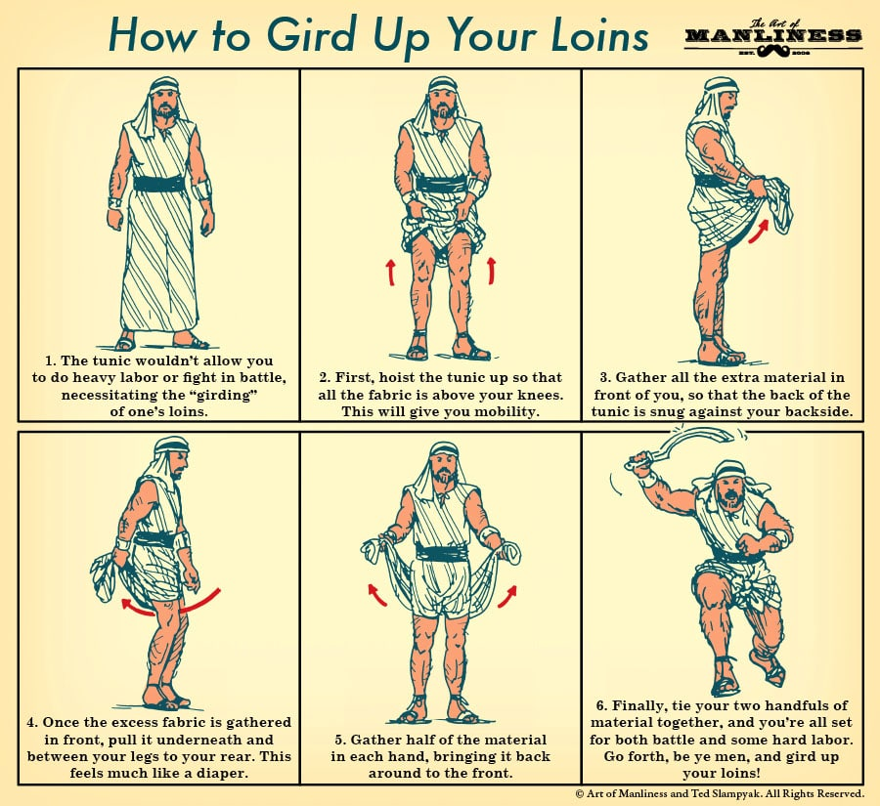

PHILEMON- A PORTRAIT OF SALVATION

Onesimus – represents us when we were yet sinners
Paul – represents Jesus Christ
Philemon – represents God the Father

It is assumed that Philemon did what Paul requested

Philemon legally owned Onesimus All men are God’s property since He is the creator – Ezekiel 18:4

Onesimus was a disobedient runaway slave “men are all gone out of the way” Rom.3:12; We are all slaves to sin Rom.5:12

Onesimus was an unprofitable slave mankind has “together become unprofitable” Rom.3:12

Onesimus stole from Philemon We robbed God of His due glory Rom.1:21

Penalty for runaway slaves was death Penalty for sin is death Ezekiel 18:20; Rom.6:23

Roman law condemned Onesimus as a The law condemns man Rom.3:20;
runaway 4:15

Onesimus could find freedom and deliverance We have freedom and deliverance
From the penalty only through Paul from sin only in Jesus Christ Rom.8:2

Paul was more than a friend to Onesimus Jesus Christ is more than a friend
And an equal partner to Philemon to sinners (Rom.5:8), and an equal partner to God the Father Phillipians 2:6

Paul offered to have Onesimus’ debt put to Our sin was put on Jesus Christ
His account 2 Corinthians 5:21

Paul offered to pay the full amount of the debt Jesus Christ paid the debt in full
Onesimus owed (see v.19) for us 1 Timothy 2:5-6

Paul brought reconciliation between Onesimus Jesus brought reconciliation
And Philemon between man and the Father
2 Corinthians 5:18-20

Onesimus could only be received by the We can only be received by the
Grace of Philemon Grace of the Father Eph.2:8

Philemon accepted Paul’s payment God the Father accepted Jesus’ payment Eph.1:6

Philemon received Onesimus as he would God receives us as He would
Paul Christ Rom.8:15-17

Onesimus was now reckoned as a brother We are reckoned as children and
And not a slave (verse 16) no more as servants Gal.4:7

Paul was the mediator between Philemon Jesus Christ was the mediator
And Onesimus between the Father and mankind
1 Timothy 2:5

Paul interceded on behalf of Onesimus Jesus Christ intercedes on behalf of us Rom.8:27

Onesimus becomes profitable to both We now are profitable to the
Paul and Philemon (v.11) Jesus Christ and the Father Eph.1:7-8

Paul could do nothing without the consent Jesus Christ could only do the will
Of Philemon of the Father John 6:38

Philemon prepared lodging for Paul God the Father received Jesus Christ into heaven where Christ is seated at the right hand of the Father Col.3:1; Eph.1:20

Chart by Bill Petri
Beacon-Ministries

DOES THE BIBLE SUPPORT SLAVERY?

DOES THE BIBLE SUPPORT SLAVERY? To answer this question, we must methodically survey the Bible and perform an exegesis on the topic.

- First we read the Scripture and reread it in its context (THE CONTEXT PRINCIPLE).
- Secondly, we want to read the Scripture in various versions.
- Thirdly we want to be sure we understand the words in the Hebrew or Greek in their original language. Did slavery mean slavery in our understanding of slavery today? We use the concordance to look up the words in their original language and we search other commentaries and dictionaries to shed light on the word and its history and translation of the word. (THE LANGUAGE GAP OR PRINCIPLE) (THE HISTORY GAP OR PRINCIPLE)

https://www.bethinking.org/bible/does-the-bible-support-slavery
“This lecture responds to the accusation that the Bible actively supports slavery. Peter J. Williams examines the issue by explaining how biblical words connected with slavery in the Old and New Testament texts have been translated and how contemporary understandings of these words have changed over the years.”

https://www.biblestudytools.com/search/?q=SLAVERY&s=References
“While the Bible does not specifically condemn the practice of slavery, it does give instructions on how slaves should be treated during those times. Scripture also mentions that humans can be slaves to sin itself, consumed by their passions. Read Bible verses about the freedom from sinful slavery that Jesus bestows us through repentance, baptism, and faith.”

- Next, we determine where in the Bible is the word or context of slavery discussed. We review them and make notes. Does each time support slavery? Does each time use the same word for slavery? How is each situation similar and different? (THE COMPARISON PRINCIPLE). How do each compare in the Old Testament to the New Testament? What can we surmise?
- Then we look to what others say about slavery in the Bible. We use commentaries and Bible dictionaries and books or articles on customs and manners of the Bible. (THE CULTURAL GAP OR PRINCIPLE) we also need to use THE GEOGRAPHICAL PRINCIPLE OR GAP to evaluate if slavery was the same in all regions, and how was it the same of different.
https://www.studylight.org/
https://www.studylight.org/dictionaries.html
http://www.ntslibrary.com/PDF%20Books%20II/Manners%20and%20Customs.pdf
❍ CHAPTER 30
SLAVERY IN BIBLE TIMES pg 391
❍ Slavery Under The Law Of Moses
❍ Slavery Under Israel's Enemies
❍ Slavery In The Roman Empire
- Additionally, we want to answer, “where is Christ seen in this topic?” (THE CHRISTOCENTRIC PRINICIPLE) Even for the Old Testament because it prefigures or foreshadows Christ, or may be a type of Christ or represents Christ in some way.
- Then we must decide based on our research what our application is for today.

- HISTORY

- Focus
- “The history of Ancient Israel is marked by periods of conquest, settlement, and exile.” https://biblehub.com/topical/t/the_cultural_context_of_ancient_israel.htm
- Definition- a chronological record of past events or subject matters. In the Bible we have an enormous collection of historical events. But the Bible is more than its history. To understand Biblical teachings for today we often gain insights from searching its historical perspective.
- Biblical History, World History, Middle East History, Greek History, Persian and Roman History are a few of the historical points of interest for us to examine as we seek to understand the Word of God in deeper context.

- Resources
- History of the Jews
- History of Israel
- Intertestamental History
- History of King Henry VIII
- Babylonian Captivity
- Alexander the Great
- History of the Tabernacle and Temple
- History of Sadducees and Pharisees

- Examples
- Haman the Agagite DT 25:17-19; 1 Sam 15:8, 32; Esther 3:1
- Israel Monarchy & Divided Kingdom
- Tabernacle & Temple History Exodus 25:8-9, 40; Hebrews 8:5
- Social Structures
“The social structure of Ancient Israel was patriarchal, with the family unit being the primary building block of society. The extended family, or "bet av," was led by the eldest male, who held authority over its members. Tribal affiliation was significant, as the twelve tribes of Israel each had distinct roles and territories. The concept of "shalom," or peace and wholeness, was central to social relations, emphasizing justice, mercy, and community responsibility (Micah 6:8).” https://biblehub.com/topical/t/the_cultural_context_of_ancient_israel.htm
- Legal and Ethical Systems
The legal system of Ancient Israel was based on the Torah, which outlined civil, ceremonial, and moral laws. Justice was to be administered impartially, with a strong emphasis on protecting the vulnerable, such as widows, orphans, and foreigners (Deuteronomy 10:18-19).

- Practice
- Discuss Esther 3:1 in the context of its history and what significance it has for understanding the Book of Esther
- Explain the history of the Monarchy and Divided Kingdoms
- In the context of history explain what is meant by the “Fullness of Time” and the “Time of the Gentile”

NOTES FOR STUDY OF ESTHER

ANCESTRY OF HAMAN, ESTHER, AND MORDECAI ESTHER 3:1

JACOB | ESAU
KING SAUL  “The first, King Saul, the first divinely appointed king over Israel, was a descendant of Jacobs youngest son, Benjamin.”  QUORA.COM | KING AGAG  SEE BELOW -AMALEKITES**
MORDECAI | HAMAN
ESTHER

DT. 25:19 BLOT OUT
1 SAM. 15: 3 GO AND SMITE AMALEK -UTTERLY DESTROY
1 SAMUEL 15:9 BUT SAUL SPARED AGAG
THE SPIRIT OF AMALEK WAS ALLOWED TO SURVIVE
JEWISH COMMENTARY= “WHAT AMALEK DID UNTO YOU”
(KORCHO) “HE ENCOUNTERED YOU OR HE COOLED YOU OFF”

**AMALEKITES. “They were the first to attack Israel as they exited Egypt. They attacked Israel repeatedly over the years of the Judges.
King Saul was commanded to annihilate the entire tribe, man, woman and child, livestock and all that pertained to them.
His disobedience ultimately cost him his throne.
Still there were remnants of Amalekites who were living elsewhere and survived and regrouped.
One of them was Haman, the son of Hammedatha, of the Royal blood of Amalek, who was Esau’s grandson.” JOURNEYONLINE.ORG

QUEEN VASHTI- GREAT GRAND DAUGHTER OF KING NEBUCHADNEZZER
MORDECAI= COUSIN ESTHER 2:7 (HIS UNCLE’S DAUGHTER)

PURIM= Purim 2026 began at sundown on Monday, March 2 , 2026 and concluded at sundown on Tuesday, March 3, 2026 The holiday of Purim falls on the Hebrew calendar date of Adar 14. ESTHER 9:17, 28

Purim in Other Years
2027: March 22-23
2028: March 9 and 11-12
2029: February 28 - March 1
2030: March 18-19
Esther 4: 13-14
FOR SUCH A TIME AS THIS
AMELEK-AMELITKITES

- Nomadic nation south of Palestine
- Not Arabs but related to the Edomites (Gen 36: 4; Gen 34:12; 1 Chron 1:36
- SON OF ESAU’S FIRST-BORN SON ELIPHAS AND THE CONCUBINE TIMNA, THE DAUGHTER OF SEIR- GRANDSON OF ESAU
- “FIRST OF THE NATIONS” Numbers 24:20
- First to come in contact with Israel after they came out of Egypt as a free nation Ex 17:8, Dt 25:17, 1 Sam 15:2
- Cruel people
  - Israel moved along as one people one group out of Egypt. The old, sic and children lagged behind. Amelekites attacked from behind –slaughtered the weak when no one could defend them- no one near to help them
  - Spirit of Esau ---Spirit of Amaelek not only despises the birthright, it seeks to destroy all those who have received the promised inheritance of the birthright.
  - Numerical value of "Amalek" is "safek", Hebrew for "doubt".

- God pledged to wipe them from existence. Memory to be blotted out Ex 17:14-16; DT 25:19
- Always appear hostile to Israel Judges 3:13, Judges 6:3,33; Judges 7:12 they help Midianites and children of the East against Israel Ps.83:7
  - That is why King Saul leads an expedition against them 1 Sam 15
- David waged sacred war of extermination against the Amalekites who retaliated 1 Sam 30

KING AGAG

- KING OF THE AMELEKITES
- Life was spared by Saul but Samuel put him to death -- about 1070 BC

OVERVIEW OF TIME PERIODS

CREATION
Adam and Eve – Garden of Eden Genesis 2

PATRIARCHS
Abraham- Leave and go to Promised Land- Canaan Genesis 12
Issac Genesis 18-25
Jacob- Twelve Tribes of Israel Genesis 25-46
***Ishmael had twelve sons also- Father of Arabic Nations Genesis 16; 21; 25

EGYPTIAN BONDAGE AND WILDERNESS WANDERING
Moses Exodus
Numbers

CONQUEST OF CANAAN Joshua
Joshua takes Israelites into the Promised Land

PERIOD OF THE JUDGES Judges
Judges raised up—Deliverance

PERIOD OF THE UNITED KINGDOM Judges 21:25 (no King)
Saul 1 Sam. 8:1-7 (Israel demands King)
1 Sam. 9-10:23-25 (Saul appt. King)
1 Sam. 15:10 (God regrets)
David 1 Sam. 16:1-7 (God selects David)
2 Sam. 2:4 (David anointed King)
2 Sam 7 (wants to build house for God)
2 Sam 7:12-17 (Seed Solomon will build)
1 Kings 2
Solomon 1 Kings 1-2 (Adonijah- Solomon King)
1 Kings 6
1 Chron 28 (Solomon builds God’s House)

DIVIDED KINGDOM
Jeroboam 1 Kings 11:26-40 (Jeroboam rebels- Ahijah)
1 Kings 12; 2 Kings 17
Israel TEN TRIBES- Northern Kingdom

Rehoboam 1 Kings 12 (Revolt against Rehoboam)
JUDAH 2 TRIBES – Southern Kingdom

PERIOD OF JUDAH ALONE
Assyria destroys Northern Kingdom 2 Kings 15:29; 2 Kings 17
(TEN LOST TRIBES OF ISRAEL) 1&2 Chronicles

BABYLONIAN CAPTIVITY 2 Kings 24-25
Jeremiah 25:12-14; 29:10-14; 52
Psalms 137
Daniel 2:47-49
Ezekiel 1:1-3
Ezra 1:2-11

PERIOD OF RESTORATION Ezra, Nehemiah, Esther, Haggai,
Zechariah, Malachi
INTERTESTAMENTAL PERIOD 400 years of silence Gal 4:4
fullness of time”
PERIOD OF CHRIST AND THE CHURCH New Testament
HISTORICAL TIMELINE AND EVENTS
(Rose Bible Timeline, 2001, chart) & other various sources)
“DATES ARE BC”
A. CREATION, THE FALL, NOAH

B. PERIOD OF THE PATRIARCHS- Abraham to Jacob’s 12 Sons -The Heads Of The Respective 12 Tribes
- Pyramids Built (2700-2200 BC)
- Abraham (2166-1991 BC)
- Abraham Covenant
- Ishmael (2080-1943)
- Isaac (2066-1886)
- Jacob (2005-1859)

C. EGYPTIAN PERIOD – From Jacob’s Descent into Egypt Until the Exodus
- Jacob flees To Haran (1929)
- Joseph (1914- 1805)
- Joseph becomes an official in Egypt (1884)
- Jacob and his family go to Egypt (1876)
- Sons Of Jacob (Israel) = 12 Tribes (Reuben, Simeon, Levi, Judah, Dan, Naphtali, Gad, Asher, Issachar, Zebulun, Joseph, Benjamin
  - Grandsons (Sons Of Joseph) – Manasseh, Ephraim
- Hammurabi Reigns in Babylon (1792-1750)- Law Code of Hammurabi
- Slavery in Egypt (Dates Unknown)
- Aaron (1529-1405)
- Moses (1526-1406)
- First Passover (1446)

D.TIME OF WILDERNESS TRAVEL AND PALESTINIAN CONQUEST
- “High date” for the exodus 1446 BC
- “Low date” for the exodus 1290 BC
- Ten Commandments and other laws given
- Tabernacle
- Joshua leads Israelites into Canaan
- Rahab helps save spies

E. PERIOD OF THE JUDGES (When the tribes lived as quite separate entities unified by common faith in God, their ancestral heritage and the central sanctuary at Shiloh)
- Era of Judges begins 1350 – Judges: Othniel, Ehud, Shamgar, Deborah, Gideon, Tola, Jair, Jephthah, Ibzan, Elon, Abdon, Samson, Eli, And Samuel
- Eli- Priest at Shiloh (1100-1060)
- Samuel- Judge and Prophet of Israel (1060-1020)

F. TIME OF UNITED MONARCHY FROM SAUL TO SOLOMON
- United Kingdom
- King Saul (1051-1011)
- King David (1011-971)
- King Solomon (971-922)
- Solomon’s Temple completed 960
G. YEARS OF DIVIDED MONARCHY WITH THESE CLOSING FOR ISRAEL AT THE FALL OF SAMARIA IN 722 BC AND FOR JUDAH AT THE FALL OF JERUSALEM IN 586
- Kingdom divides 922 – when King Solomon died 10 tribes refused to follow his son Rehoboam and revolted. Israel divides into 2 kingdoms.
- Northern Kingdom = Israel (Samaria made capital) 10 tribes
- Southern Kingdom = Judah (Jerusalem capital) 2 tribes (Judah & Benjamin)
- They experienced an assortment of disobedient, corrupt, and ineffective kings. In the book of judges when the Hebrew people first asked for a king, they were told that Yahweh (YHWH) was their king. It was an act of disobedience when they told Samuel of their desire for a King (Judges, 1 & 2 Kings)
- In 722 BC, Assyria conquers the Northern Kingdom (Israel) and forced the 10 tribes to scatter throughout their empire (Diaspora). Assyria settles in the capital of Israel (Samaria) and brought with them their gods and cultic practices. In biblical days, people who conquered other lands feared the god or gods of that land. Within a short time, the Assyrians would be worshipping Yahweh exclusively. This produced a schism (division) between the Jews and the Samaritans. While the Samaritans (Assyrians) adopted the Hebrew God and worship practices, they differed with the Jews on this account; they believed they could sacrifice to God outside of the temple in Jerusalem. The Jews were outraged that the Samaritans would dare sacrifice to Yahweh outside of the temple in Jerusalem. This division played a major role in the rhetoric of Jesus in the New Testament
- Judah (Southern Kingdom) barely escaped the Assyrian takeover until later in 701. Assyrian king Sennacherib invades Judah in 701
- 621- book of the law found in temple
- 612- Nineveh conquered by Babylon
- 609- Egypt and Assyria defeat Babylon- Egypt gets Judah and neighbors
- 605-Babylon defeats Egypt, Judah becomes a vassal (slave-servant-subordinate)
- 597- Jerusalem conquered by Babylon
- 587/6-Babylon destroys Jerusalem and temple

H. EXILE AND POSTEXILIC PERIOD UNTIL CLOSE OF THE 4TH CENTURY
- Judean Jews are exiled to Babylon as Jeremiah had prophesied (Jer. 25:9-12) (controversial topic)
- 539- Cyrus the great (Persian emperor) conquers Babylon
- 538- Cyrus issues edict empowering Jewish exiles to return to Jerusalem and rebuild the temple (2 K. 17). Jews returned home in three phases
  - 1st – 538 BC (Ezra 1-6--2 chronicles 36:22-23; Ezra 1:1-4). Purpose was to provide the law and restore worship- led by Ezra. Jewish leader Zerubbabel under Cyrus the Persian leader—anyone who wanted to return could go home. Royal treasury paid for rebuilding the temple. Gold and silver worship articles taken from the temple were returned. The Ark of the covenant was not returned. To this day it is “lost”
  - 2nd – 457/8 BC (Ezra 7-10) Jewish leader Ezra- Persian ruler Artaxerxes Longimanus – anyone who wanted to go home could- Royal treasury provided funding- Jewish civil magistrates and judges were allowed
  - 3rd 444 BC- (Nehemiah 1-13) Nehemiah was Jewish leader – Persian leader still Artaxerses- rebuilding of Jerusalem was allowed. Purpose was to rebuild the city walls.
- 515- Temple completed

HISTORICAL TIMELINE
UNITED KINGDOM
SAUL -1051-1011
DAVID -1011-971
SOLOMON- 971-922
922 KINGDOM DIVIDES
SOUTHERN KINGDOM |  |  | NORTHERN KINGDOM
PROPHET | EVENT & KING |  | PROPHET | EVENT & KING
 | 922 REHOBOAM |  |  | 922  JEREBOAM I
 | 783-742 UZZIAH |  | ELIJAH | 878-845 OMRI DYNASTY  OMRI  AHAB
MICAH  ISAIAH | AHAZ |  | ELISHA | 853 BATTLE OF QARQAR – ASSYRIA STOPPED
 | HEZEKIAH  701 SENNACHERIB (ASSYRIAN KING- SON OF SARGON II WHO ATTACKED NORTHERN KINGDOM) INVADES JUDAH  MANASSEH  AMON  JOSIAH |  |  | 845-746 JEHU DYNASTY
HULDAH | 621 BOOK OF LAW FOUND IN TEMPLE |  |  | 841 SHALMANESER III- SYRIAN CAMPAIGN
NAHUM  JEREMIAH | 612 NINEVAH CONQUERED BY BABYLON  JEHOAHAZ |  | AMOS  HOSEA | 802 ADA-NIRARI III CONQUERS DAMASCUS  JEREBOAM II  786-746  MENAHEM  PEKAH  HOSHEA
 | 609 EGYPT & ASSYRIA DEFEAT BABYLON  EGYPT GETS JUDAH & NEIGHBORS  JEHOIAKIM |  |  | 724 SHALMANESER V ATTACKS SAMARIA
ZEPHANIAH | 605 BABYLON DEGEARS EGYPT, JUDAH BECOMES VASSAL  JEHOIACHIN |  |  | 722 SAMARIA FALLS TO SARGON II  END OF NORTHERN KINGDOM
EZEKIEL | 597 JERUSALEM CONQUERED BY BABYLON  ZEDEKIAH LAST KING OF JUDAH
HAGGAI  ZECHARIAH | 539 CYRUS (PERSIAN EMPEROR) CONQUERS BABYLON
 | 538 CYRUS SIGNS EDICT TO EMPOWER JEWISH EXILES TO RETURN TO JERUSALEM
MALACHI | 515 TEMPLE COMPLETED (REBUILT)

KINGS OF THE DIVIDED KINGDOMS
# | Kings of the Northern Kingdom: Israel (19 Kings) | Kings of the Southern Kingdom: Judah  (20 Kings + 1 Queen)
1 | Jeroboam I – Led the revolt, set up golden calves at Bethel and Dan (1 Kings 12:25-33) | Rehoboam – Son of Solomon, lost ten tribes  (1 Kings 12)
2 | Nadab – Son of Jeroboam, reigned briefly (1 Kings 15:25-26) | Abijah (Abijam) – Continued war with Israel (1 Kings 15:1-8)
3 | Baasha – Killed Nadab, ruled by force (1 Kings 15:27-28) | Asa – Long reign, religious reforms  (1 Kings 15:9-24)
4 | Elah – Son of Baasha, assassinated while drunk  (1 Kings 16:8-10) | Jehoshaphat – Alliance with Ahab, judicial reforms  (1 Kings 22; 2 Chronicles 17)
5 | Zimri – Reigned 7 days, committed suicide  (1 Kings 16:15-20) | Jehoram – Married Ahab’s daughter, killed brothers (2 Kings 8)
6 | Omri – Military commander, began dynasty (1 Kings 16:21-28) | Ahaziah – Killed by Jehu  (2 Kings 9)
7 | Ahab – Son of Omri, married Jezebel, opposed Elijah  (1 Kings 16:29–22:40) | Athaliah (Queen) – Mother of Ahaziah, seized throne, only queen  (2 Kings 11)
8 | Ahaziah – Son of Ahab, reigned briefly  (1 Kings 22:51–53) | Joash (Jehoash) – Repaired temple  (2 Kings 12)
9 | Joram (Jehoram) – Another son of Ahab  (2 Kings 3) | Amaziah – Killed by conspirators  (2 Kings 14)
10 | Jehu – Anointed by Elisha, known for bloody reforms (2 Kings 9–10) | Uzziah (Azariah) – Long prosperous reign  (2 Kings 15:1-7)
11 | Jehoahaz – Son of Jehu (2 Kings 13:1-9) | Jotham – Faithful king (2 Kings 15:32-38)
12 | Jehoash (Joash) – Victories over Aram (2 Kings 13:10-25) | Ahaz – Idol worship, closed the temple (2 Kings 16)
13 | Jeroboam II – Period of prosperity (2 Kings 14:23-29) | Hezekiah – Religious revival, trusted God against Assyria (2 Kings 18–20)
14 | Zechariah – Assassinated quickly (2 Kings 15:8-12) | Manasseh – Longest reign, much evil, later repented (2 Kings 21)
15 | Shallum – Reigned one month (2 Kings 15:13-15) | Amon – Brief evil reign (2 Kings 21:19-26)
16 | Menahem – Cruel reign, paid tribute to Assyria (2 Kings 15:16-22) | Josiah – Rediscovered the law, religious reform (2 Kings 22–23)
17 | Pekahiah – Son of Menahem  (2 Kings 15:23-26) | Jehoahaz – Reigned 3 months  (2 Kings 23:31-34)
18 | Pekah – Military leader, opposed Assyria  (2 Kings 15:27-31) | Jehoiakiam- Oppressed people, burned Jeremiah’s scroll (2 Kings 23:35-24:7)
19 | Hoshea – Last king before Assyrian exile  (2 Kings 17) | Jehoiachin – Exiled to Babylon  (2 Kings 24:8-17)
20 | --------------- | Zedekiah – Last king of Judah, witnessed destruction of Jerusalem (2 Kings 24:18–25:21)
https://www.pastorjasonelder.com/bible-facts-all/kings-of-israel-and-judah-complete-list-timeline
BABYLONIAN CAPTIVITY

LAST KINGS OF JUDAH
Josiah | 640-609
Jehoahaz | 609-608
Jehoiakim/Eliakim | 608-597
Jehoiachin | 597
Zedekiah | 597-587

A CLOSER LOOK

- PERIOD OF JUDGES
- ISRAEL KINGDOM UNITED MONARCHY- SAUL—DAVID--SOLOMON
- KINGDOM DIVIDES 922 BC -- BECAUSE 10 TRIBES REFUSED TO FOLLOW REHOBOAM
- NORTHERN KINGDOM = ISRAEL—SAMARIA IS MADE CAPITAL
- SOUTHERN KINGDOM= JUDAH- JERUSALEM IS MADE CAPITAL

- 722 ASSYRIA CONQUERS NORTHERN KINGDOM – 10 TRIBES SCATTER (DIASPORA)
- THE END OF THE NORTHERN KINGDOM.

- JUDAH ESCAPED ASSYRIAN UNTIL 701 BC
- 701 BC SENNACHERIB INVADES JUDAH
- 612 NINEVAH (CAPITAL OF ASSYRIA) CONQUERED BY BABYLON
- 609 EGYPT AND ASSYRIA DEFEAT BABYLON (EGYPT GET JUDAH AND NEIGHBORS
- 605 BABYLON DEFEATS EGYPT, JUDAH BECOMES A VASSAL (SLAVE-SBORDINATE)
- 597- BABYLON CONQUERS JERUSALEM
- 587/6 BABYLON DESTROYS JERUSALEM AND TEMPLE

LAST 4 KINGS OF JERUSALEM
BEFORE SHE FELL TO BABYLON

JOSIAH (Good) (1 Chron 3: 15-16)
Found the Book of the Law, Renewed the covenant,
tore down the high places of idol worship, destroyed the priests of false gods,
reinstituted the Passover, turned to the Lord with his whole heart and soul and strength, in accorandance with the Law of Moses
2 Kings 23:25
Sons did not rule in their birth order

4. SHALLUM (evil)
(JEHOAHAZ) 609/8 BC
-2 Chron. 36:1-2
-Became King at 23
-2 Kings 23:31; 2 Chron. 36:1-3, 5,; 1 Chron. 3:15
-Reigned for 3 months
-FIRST of the sons to become King but was lastborn of Josiah. Chosen by the people.
- Was taken by Pharaoh Necho and the Pharaoh installed Jehoahaz’s brother, Eliakim, as King
-Died in Egypt (2 Kings 23:25-26;
4. SHALLUM (evil)
(JEHOAHAZ) 609/8 BC
-2 Chron. 36:1-2
-Became King at 23
-2 Kings 23:31; 2 Chron. 36:1-3, 5,; 1 Chron. 3:15
-Reigned for 3 months
-FIRST of the sons to become King but was lastborn of Josiah. Chosen by the people.
- Was taken by Pharaoh Necho and the Pharaoh installed Jehoahaz’s brother, Eliakim, as King
-Died in Egypt
(2 Kings 23:25-26;
1. JOHANAN
-1 Chron. 3:15
-Believe that he must have died early
2. JEHOIAKIM (evil) (Jer. 26:1)
(ELIAKIM) (2 Chron. 36:4)
-Became King Jerusalem at 25
-Reigned 11 years 2 Kings 23:36; 2 Chron. 36:5
-608-597
-Pharoah made him King and renamed him Jehoiakim
-Taken captive by King Neb. In chains to Babylon-same time as Daniel
- Was later returned to Jerusalem but was King Neb. ‘s servant- paid tribute (tax) for 3 years–During this time Jeremiah was preaching in Jerusalem
-Jehoiakim burned the scroll but Jeremiah rewrote it (Jer. 36:27-31)
-SECOND of Josiah’s sons to become King to become King although he was 2nd born

3. ZEDEKIAH (evil)
-Became King Jerusalem at 21
-Reigned 11 years
-2Chron. 36:10; 2 Kings 24:17
THIRD SON OF JOSIAH to become King of Jerusalem but after the grandson of Josiah so the last of the sons to rule over Jerusalem
-Jerusalem fell to King Neb. After his 11 year reign—Temple destroyed, walls burned, palaces destroyed

-Jehoiakim had a son
-JEHOIACHIN—(evil)
- (ALSO KNOWN AS JECONIAH & CONIAH)
-Became King at 8 years old
-Reigned 3 months and 10 days (2 Chron. 36:9-10) 597 BC
-Was taken to Babylon prisoner along with his mother
-3RD to assume the Throne – grandson of Josiah
-Among the 2nd deportation of Jews along with 10,000 others
King Neb. Installed Zedekiah to the throne
-Later after King Neb. ate at the King’s Merodach table (Babylon)
2 Kings 25:28; Jer. 52:32-34

CAPTIVITY OF JUDAH
- THREE INVASIONS
- COVERED PERIOD OF 20 YEARS

1ST INVASION
607-605 BC -Daniel and his friends carried into captivity 2 Kings 24:1; Jeremiah 241; Daniel 1: 1-7

2ND INVASION
597 BC- Jehoiakim king of Judah, AND 10,000 PEOPLE CARRIED INTO CAPTIVITY
Ezekiel was among them.

3rd INVASION
587/6 Jerusalem was conquered by Babylon with her walls, palace, and the Temple. The Temple was destroyed. All the vessels and furniture of the Temple were taken.
The inhabitants were carried away into exile.
2 Kings 24:18, 1-27; 2 Chronicles 36: 11-21; Jeremiah 52: 1-11; Jeremiah 25: 9-12

THE END OF THE SOUTHERN KINGDOM JUDAH.
Israel became restored as a nation in 1948.

POST EXILE RETURNS
BOOKS OF EZRA, NEHEMIAH, HAGGAI, ZECHARIAH, MALACHI SOME OF ISAIAH, JEREMIAH

- JEWS RETURN IN THREE PHASES

539- King Cyrus of Persia conquers Babylon.
538- He issues edict allowing the Jews to return to Jerusalem.

1ST RETURN
538 BC – Jewish leader Zerubbabel returns and rebuilds the Temple – completed in 515 BC. Persian King Cyrus.

2nd RETURN
458/7 - Jewish leader Ezra returns and restores worship. Persian ruler Artaxerxes Longimanus.

3rd RETURN
444 BC- Nehemiah returns and rebuilds the wall around Jerusalem. Persian leader still Artaxerxes.
Esther and Mordecai stay in Persia.

COMPARISON “FULLNESS” AND “TIMES” OF THE GENTILES

Criteria | “Fullness of the Gentiles” | “Times of the Gentiles”
Scripture | Romans 11:25-27 | Luke 21:24
Began and End | Began day of Pentecost  Ends at the Rapture | Began at the Babylonian Captivity  Ends at the Second Coming
Differentiating factor | Numerically, referring to when the last person becomes part of the Church before she is raptured. The time of the Church when she was born to when she will be raptured. | From the time Israel politically came under domination of the Gentile rule.

- GEOGRAPHY

- Focus
- Study of places and relationship between people and their environments
- The study of the earth and its features and of the distribution of life on the earth, including human life and the effects of human activity.
- Places and names of places change
- Terrains change

- Resources
- Biblical and World Maps
- Biblical and World Atlas

- Examples
- Babylon is modern day Iraq
- Persia is modern day Iran
- Asia Minor is modern day Turkey
- Aram is Syria today
- https://en.wikipedia.org/wiki/List_of_modern_names_for_biblical_place_names
- https://bibletrueevidences.blogspot.com/2017/12/list-of-biblical-places-are-real-list.html

- Practice
- Are Arameans Syrians? Shem became the father of Aram, whose descendants became the people known as Arameans (Genesis 10:22) Aram was the Hebrew designation for the nation of Syria, so the Arameans mentioned in the Bible are Syrians.
  - https://www.gotquestions.org/who-Arameans.html
- What is the difference between Syria and Assyria? The main difference between Syria and Assyria is that Syria is a modern nation located in West Asia, while the Assyrian was an ancient empire that came into existence around the twenty-third century BC. Syria is a present-day well-developed and modernized country having a dominant Muslim population, while Assyrians consisted of people from regions of Iraq, Turkey, and Syria.
  - https://askanydifference.com/difference-between-syria-and-assyria/

THE PRINCIPLES

THE SOURCE
Conner, Kevin J. and Ken Malmin. Interpreting the Scripture: A Textbook on How to Interpret the Bible. Portland: City Bible Publishing, 1983.

- CONTEXT PRINCIPLE

- Focus
- Context –Context—Context is to Biblical Interpretation as Location—Location _Location is to Real Estate
- Prevents “wrong” interpretation of Scripture
- Prevents one from making Scripture say what we want it to say to fit our pretext (A reason or excuse given to hide the real reason for something)
- “In relation to Scripture, it signifies the connection of thought running through either the whole of Scripture, a Testament, a book of the Bible, or a particular passage.”
- The context of a:
Verse Passage Book Testament Whole Bible
- Consider the Historical Context, the Cultural Context, the Literary Context, the Immediate Context and the Theological Context

- Resources
- Conner, Kevin J. and Ken Malmin. Interpreting the Scripture: A Textbook on How to Interpret the Bible. Portland: City Bible Publishing, 1983.
- Any source or book dealing with Biblical Interpretation

- Examples
- Hebrew 10:38 (PP54-55)
  - Passage context-- (Hebrews 10:19-12:2) subject matter of passage is faith
  - Book context-- the goal of the Book is faith in Christ as the mediator between God and man
  - Testament context—Romans 1:17 JUST; Galatians 3:11 LIVE; Hebrews 10:38 FAITH
  - Whole of Scripture context-- …Only through righteous which is by faith

- Practice

- Examine the context of Luke 10:37
37 And he said, He that shewed mercy on him. Then said Jesus unto him, Go, and do thou likewise.

- Examine the context of John 10:10
1“Truly, truly, I say to you, he who does not enter by the door into the fold of the sheep, but climbs up some other way, he is a thief and a robber. 2“But he who enters by the door is a shepherd of the sheep. 3“To him the doorkeeper opens, and the sheep hear his voice, and he calls his own sheep by name and leads them out. 4“When he puts forth all his own, he goes ahead of them, and the sheep follow him because they know his voice. 5“A stranger they simply will not follow, but will flee from him, because they do not know the voice of strangers.” 6This figure of speech Jesus spoke to them, but they did not understand what those things were which He had been saying to them. 7So Jesus said to them again, “Truly, truly, I say to you, I am the door of the sheep. 8“All who came before Me are thieves and robbers, but the sheep did not hear them. 9“I am the door; if anyone enters through Me, he will be saved, and will go in and out and find pasture. 10“The thief comes only to steal and kill and destroy; I came that they may have life, and have it abundantly. 11“I am the good shepherd; the good shepherd lays down His life for the sheep. 12“He who is a hired hand, and not a shepherd, who is not the owner of the sheep, sees the wolf coming, and leaves the sheep and flees, and the wolf snatches them and scatters them. 13“He flees because he is a hired hand and is not concerned about the sheep. 14“I am the good shepherd, and I know My own and My own know Me, 15even as the Father knows Me and I know the Father; and I lay down My life for the sheep. 16“I have other sheep, which are not of this fold; I must bring them also, and they will hear My voice; and they will become one flock with one shepherd. 17“For this reason the Father loves Me, because I lay down My life so that I may take it again. 18“No one has taken it away from Me, but I lay it down on My own initiative. I have authority to lay it down, and I have authority to take it up again. This commandment I received from My Father.” 19A division occurred again among the Jews because of these words. 20Many of them were saying, “He has a demon and is insane. Why do you listen to Him?” 21Others were saying, “These are not the sayings of one demon-possessed. A demon cannot open the eyes of the blind, can he?”

- THE FIRST MENTION PRINCIPLE

- Focus
- Considering the first time the subject appears in Scripture
- The first time a thing is mentioned in Scripture carries with it a meaning which will be consistent throughout the Bible

- Resources
- Refer to Conner and Malmin
- Bible (complete Book rather than compilation of various Books)
- Strong’s Concordance

- Examples
- Gen. 1:1-3 First mention of the principle word and spirit agreement
- Gen 1: 27-28 First mention of the Kingship and dominion principle
- Gen 1:1 First mention of the event of creation
- Gen. 3: 1-7 First mention of the event of the fall of man

- Practice
- Find the first mention of Babylon (Gen 10:10)
- Find the first Messianic prophecy mentioned (Gem. 3:5)

- THE COMPARATIVE MENTION PRINCILE
- Focus
- Verse or group of verses may be interpreted by comparing /contrasting it with another verse or group of verses
- Compare spiritual things with spiritual (1 Cor 2:13)

- Resources
- Refer to Conner and Malmin
- Bible
- Commentaries

- Examples
- DT 28:1-6, 15-19 blessings and curses compared
- Hebrews 8:2, 5, 8-12; 2 Cor 3:1-18 Tables of stone cp tables of heart

- Practice
- 1 Cor 15:45-49 Compare the First Adam to the Last Adam
- Romans 5:12-21 Compare man’s obedience and disobedience

4. THE PROGRESSIVE MENTION PRINCIPLE

- Focus
- God’s word is a progressive revelation given by God to man
- Successive unfolding of a continuous theme to its consummation
- An extension of the first mention principle and part of a complete mention principle

- Resources
- Refer to Conner and Malmin
- Bible
- Commentaries
- Strong’s Concordance

- Examples
- Agreement of the Spirit and the Word
- Gen 1:1-3
- 2 Sam 23:2
- 2 Chronicles 20:14, 15
- Isaiah 61:1
- John 1:14, 32
- Acts 10: 44
- Ephesians 6:17
Fall of Man
- Gen 3:1-7
- Job 31:33
- Romans 5:12-21
- 1 Cor 15:22
- 1 Timothy 2:13,14

- Practice
- Forgiveness of sin through the shedding of blood. Without the shedding of blood there is no remission…. Hebrews 9:22.
- Gen 4:10-11
- Gen 9:4
- Exodus 12
- Exodus 24:8
- Leviticus 17:10-14
- Luke 22:20
- Romans 5:9
- Ephesians 1:7
- Hebrews 13:20
- Revelation 12:11

- THE COMPLETE MENTION PRINCIPLE

- Focus
- Searching out the full truth of a subject in the Word.
- Total aggregate of references to any individual subject in Scripture.

- Resources
- Refer to Conner and Malmin
- Bible
- Commentaries
- Strong’s Concordance

- Example
- Complete mention of leaven (Read all from Conner and Malman)

- Practice
- Keys in the Bible
- Judges 3:25
- Isaiah 22:22
- Mt. 16:19
- Luke 11:15
- Rev. 1:18
- Rev. 9:1
- Rev. 20:1

6. THE CHRISTO-CENTRIC PRINCIPLE

- Focus
- At the center of God’s Word is Christ. The Word revolves around Him. He is the Living Word. Then said I, Lo, I come (in the volume of the book it is written of me,) to do thy will, O God. Hebrews 10:7
- Where do we see Christ in the Sciptures?

- Resources
- Refer to Conner and Malmin
- Bible
- Commentaries
- Strong’s Concordance

- Examples
- Genesis-- The Creator, The Beginning, The seed of a woman, Joseph…
- Exodus-- The Deliver, The Mediator, The Lawgiver, The High Priest, The Passover Lamb..

- Practice
- 2 Kings 4:38-41

- THE SYMBOLIC PRINCIPLE

1. Focus
- Symbolism is often used in the Bible
- We interpret the Bible literally but we don’t ignore the rich language, metaphors and symbolism as we interpret
- Symbol-- using one thing to represent or stand for another- has a deeper alternative meaning in addition to the plain and obvious
- Some symbols: objects, creatures, actions, directions, names, colors

- Resources
- A to Z Guide to Bible Signs and Symbols (Baker Publishing)
- https://www.biblestudy.org/beginner/meaning-of-symbolic-words-in-bible.html
- https://amazingdiscoveries.org/RT_encyclopedia_Revelation_Daniel_symbols#!
- https://www.gotquestions.org/biblical-symbolism.html
- https://chicagobible.org/symbols-and-meanings-throughout-the-bible/

- Example
- Ark of the Covenant symbolizes the presences of God
- Dove symbolizes peace and the Holy Spirit
- To walk with God signifies living in fellowship with God and reflecting His character
- Flowing with milk and honey speaks to abundance, lush, and fertile

- Practice
- What does Peter symbolize? The Rock? Mt. 16:18 The rock is a deep foundation upon which the Church would be built
- Find 2 Scriptures using symbolic language and interpret it

JESUS AND THE TABERNACLE

The Old Testament is very relevant for us today for it points us to Christ. We can see one example of this in the Tabernacle. God wanted to live among His people and commanded Moses to build a Sanctuary after the pattern shown to him in the Mount (Exodus: 25:8-9, 40; Hebrews 8:5). The pattern of the Tabernacle is described in Exodus 25-40. Every part of this “tent of meeting” points us to Christ, even down to the color and materials. Let us examine merely the furniture.
The tent was surrounded by a wall. Immediately inside the wall was the Outer Court where there were two pieces of furniture; the Brazen Altar and the Laver of Brass. People would enter the gate into the Outer Court to bring their animal sacrifice. The sacrifice would be burned on the Brazen Altar and the blood reserved for the High Priest to carry it into the Holy of Holies on the Day of Atonement (Yom Kippur) for the remission of sin. Thank God for Jesus who was the final sacrifice. His blood was shed for the remission of all sin. It was finished on the cross and through His resurrection.
The second piece of furniture in the Outer Court was the Brazen Laver. Here the priests would cleanse themselves before going into the Sanctuary called the Inner Court or the Holy Place. The laver is said to be made of the women’s make up mirrors. The priests washed their hands and seeing their reflection, must examine themselves before entering. Only the Lord Jesus can cleanse us and cause us to see who we were before He saved us and who we are in Christ!
The Holy Place or the Inner Court has three pieces of furniture. The Table of Shewbread represents Jesus as the Bread of Life. During the week, the priests ate twelve bread loaves, one from each tribe and each week it was replaced. Bread has sustaining power just as our Lord who gives us life and life everlasting.
The Menorah or the Lampstand was the light for the Sanctuary. The candle was made of one piece of solid gold and the center foundation represents Jesus, who is our foundation. Jesus is the Light of the World and through His Holy Spirit we can be enlightened and illuminated. We are light to a dark world because of Christ and what He did in us.
The Altar of Incense represents the prayers of the saints. It is a sweet aroma that comes before the Lord Jesus.
The Holy of Holies or The Most Holy Place is the place behind the veil, where God would meet with the High Priests on behalf of His people. Only the High Priests could go inside the Holy of Holies and only once a year on Yom Kippur. He would sprinkle the blood sacrifices to atone for the sins of the people. There was only one piece of furniture called the Ark of the Covenant behind the curtain. The Ark represents the presence of God because He would manifest as a pillar and cloud from the Mercy Seat. Inside the Ark were three items: the manna, the rod of Aaron, and the tablets of the Ten Commandments.
When Christ, the genuine High Priest, died for us over 2000 years ago, the veil to the Holy of Holies of the Temple was ripped from top to bottom. Thereby, all the people who choose God, can have access to His presence. In His presence we can find salvation, healing, safety, love, and grace.
The Tabernacle has so much more significance and I encourage you to read Hebrews 8-10.

TABERNACLE – TEMPLE

1. Exodus 25:8 --- God tells Moses to build a sanctuary
John 1:14
Rev. 7:15; 12:12; 13:6; 21:3

2. 1 Chronicles 17 and 2 Samuel 7---- David wants to build a house for God -- A Temple but God says no

3. 1 Chronicles 22:8 --- God explains why David cannot build the house—man of war—much blood on hands--- David will have a son and he will build the house

4. 1 Kings 6 and 2 Chronicles 3---Solomon builds the Temple

5. 2 Kings 24:11---King Nebuchadnezzar attacks Jerusalem (587 BC) -- v 13 carried out all the treasuries

6. 2 Kings 25:9 ---Destruction of Solomon Temple --

7. Ezra 3:8 ---Jews return to Jerusalem and Zerubbabel begins to rebuild Temple

8. Antiquities of the Jews 15.11.2---Josephus documents King Herod rebuilds Second Temple

9. Mark 13.2; Mt 24:1-8; luke 21:5-6 ---Jesus prophesies that the Temple of King Herod would be destroyed

TABERNACLE -TEMPLE TIMELINE

TABERNACLE OF MOSES---FIRST TEMPLE- SOLOMON-----SECOND TEMPLE- ZERUBBABEL----SECOND TEMPLE-KING HEROD
1450 BC-----------------------------COMPLETED 957 BC---------------COMPLETED 515 BC-----------------------COMPLETED AD 63--FELL AD 70

TABERNACLE -TEMPLE FURNITURE

OUTER COURT INNER COURT (HOLY PLACE) HOLY OF HOLIES (MOST HOLY PLACE)

1.BRAZEN ALTAR 1. TABLE OF SHEWBREAD 1. ARK OF THE COVENANT

2. BRAZEN LAVER 2. MENNORAH A. MANNAH
B. TEN COMMANDMENTS
3. ALTAR OF INCENSE C. AARON’S ROD

Islamic Mosque sits on Temple Mount today in Jerusalem
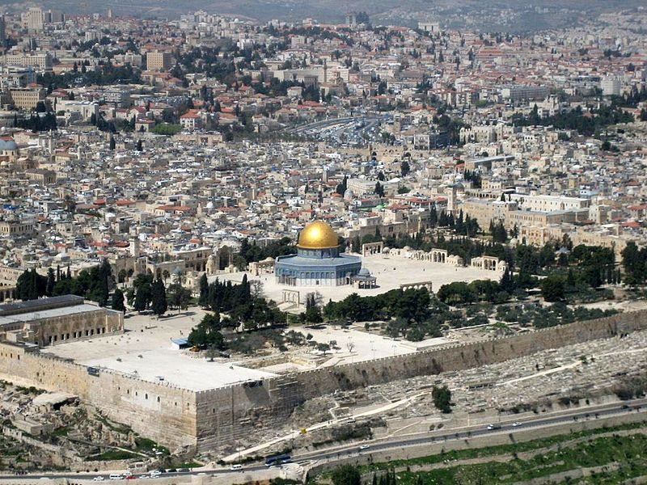
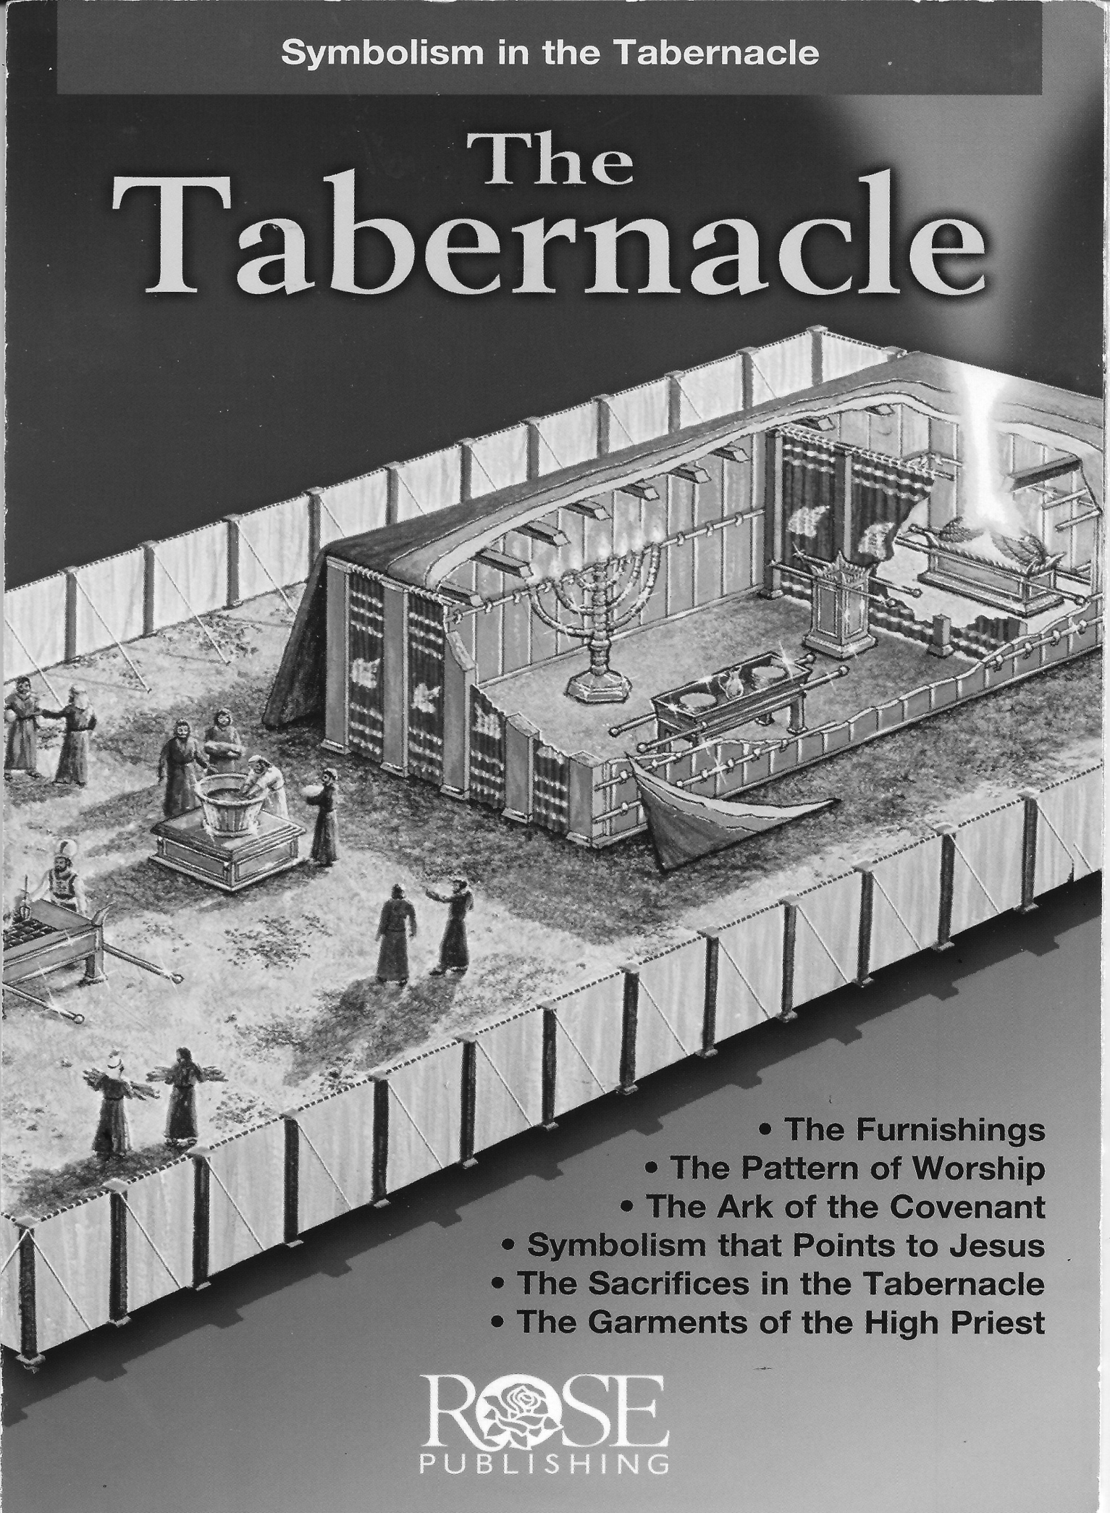
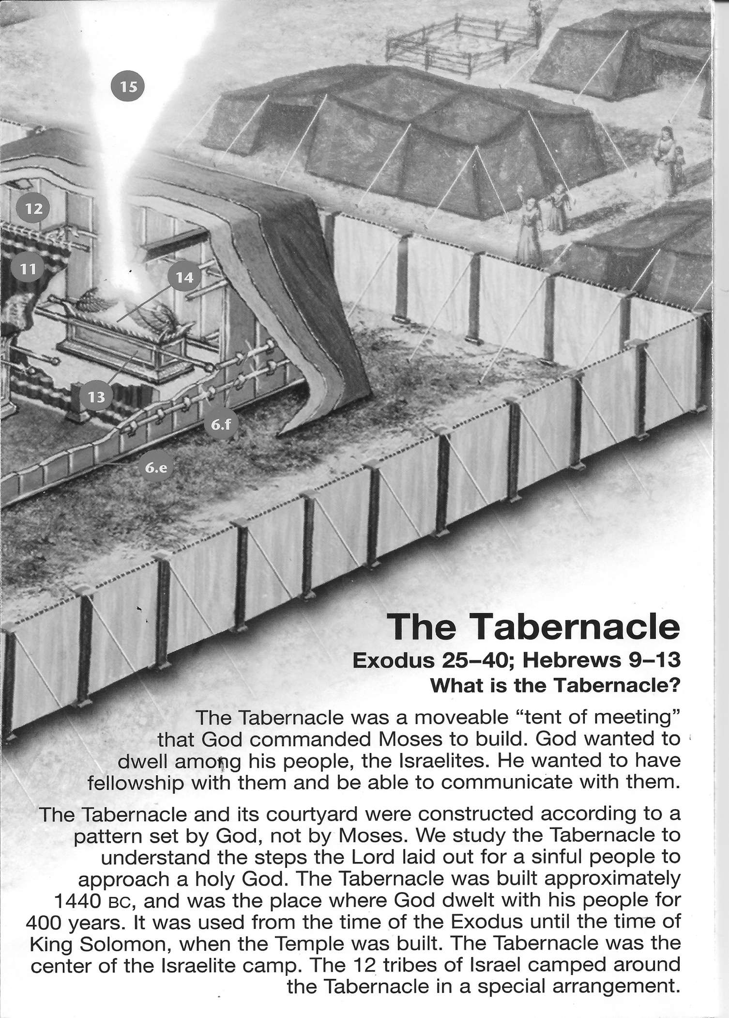
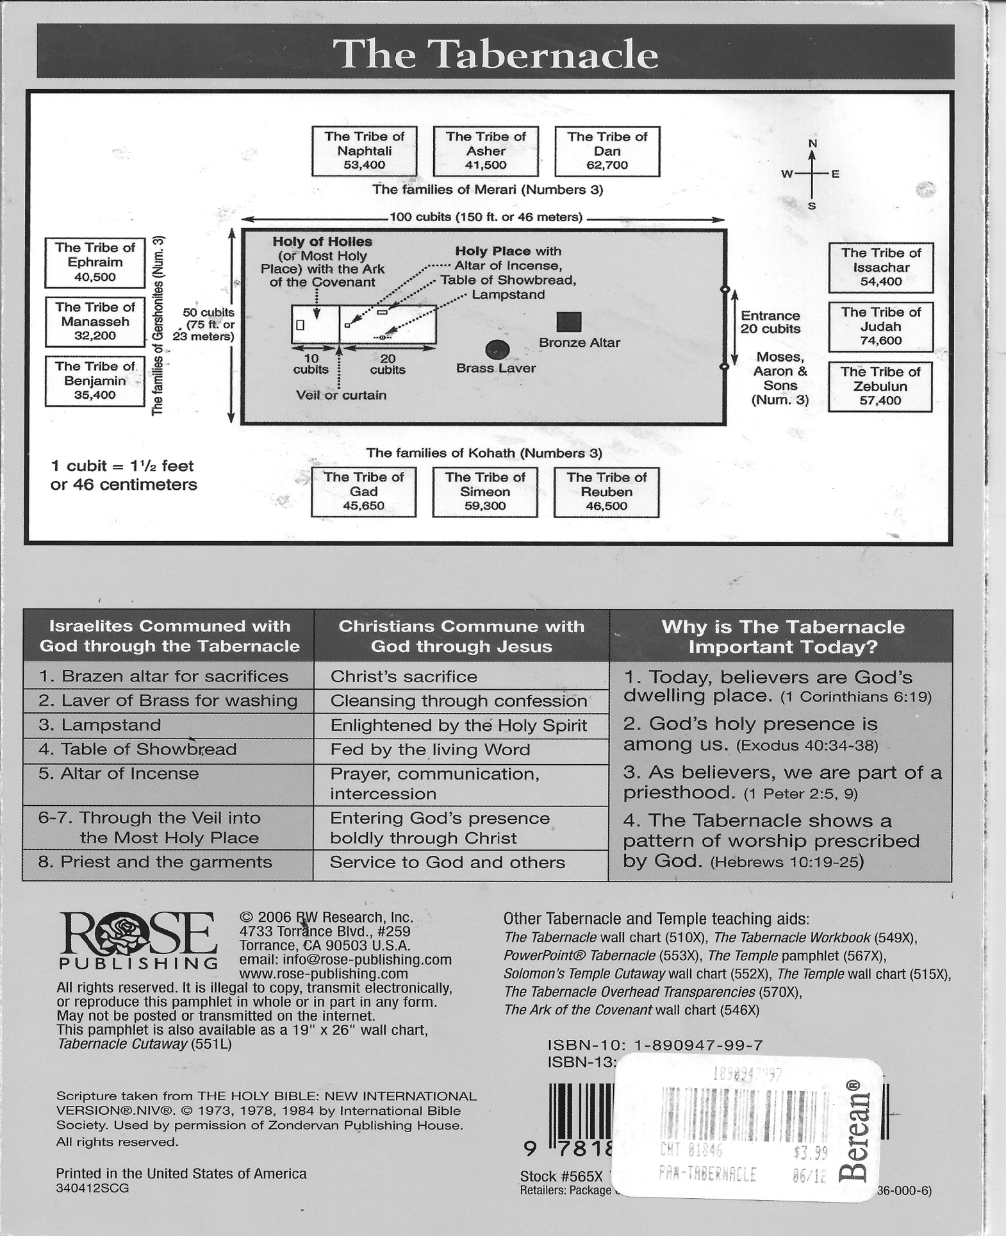

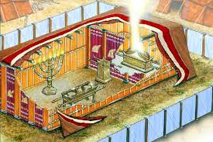

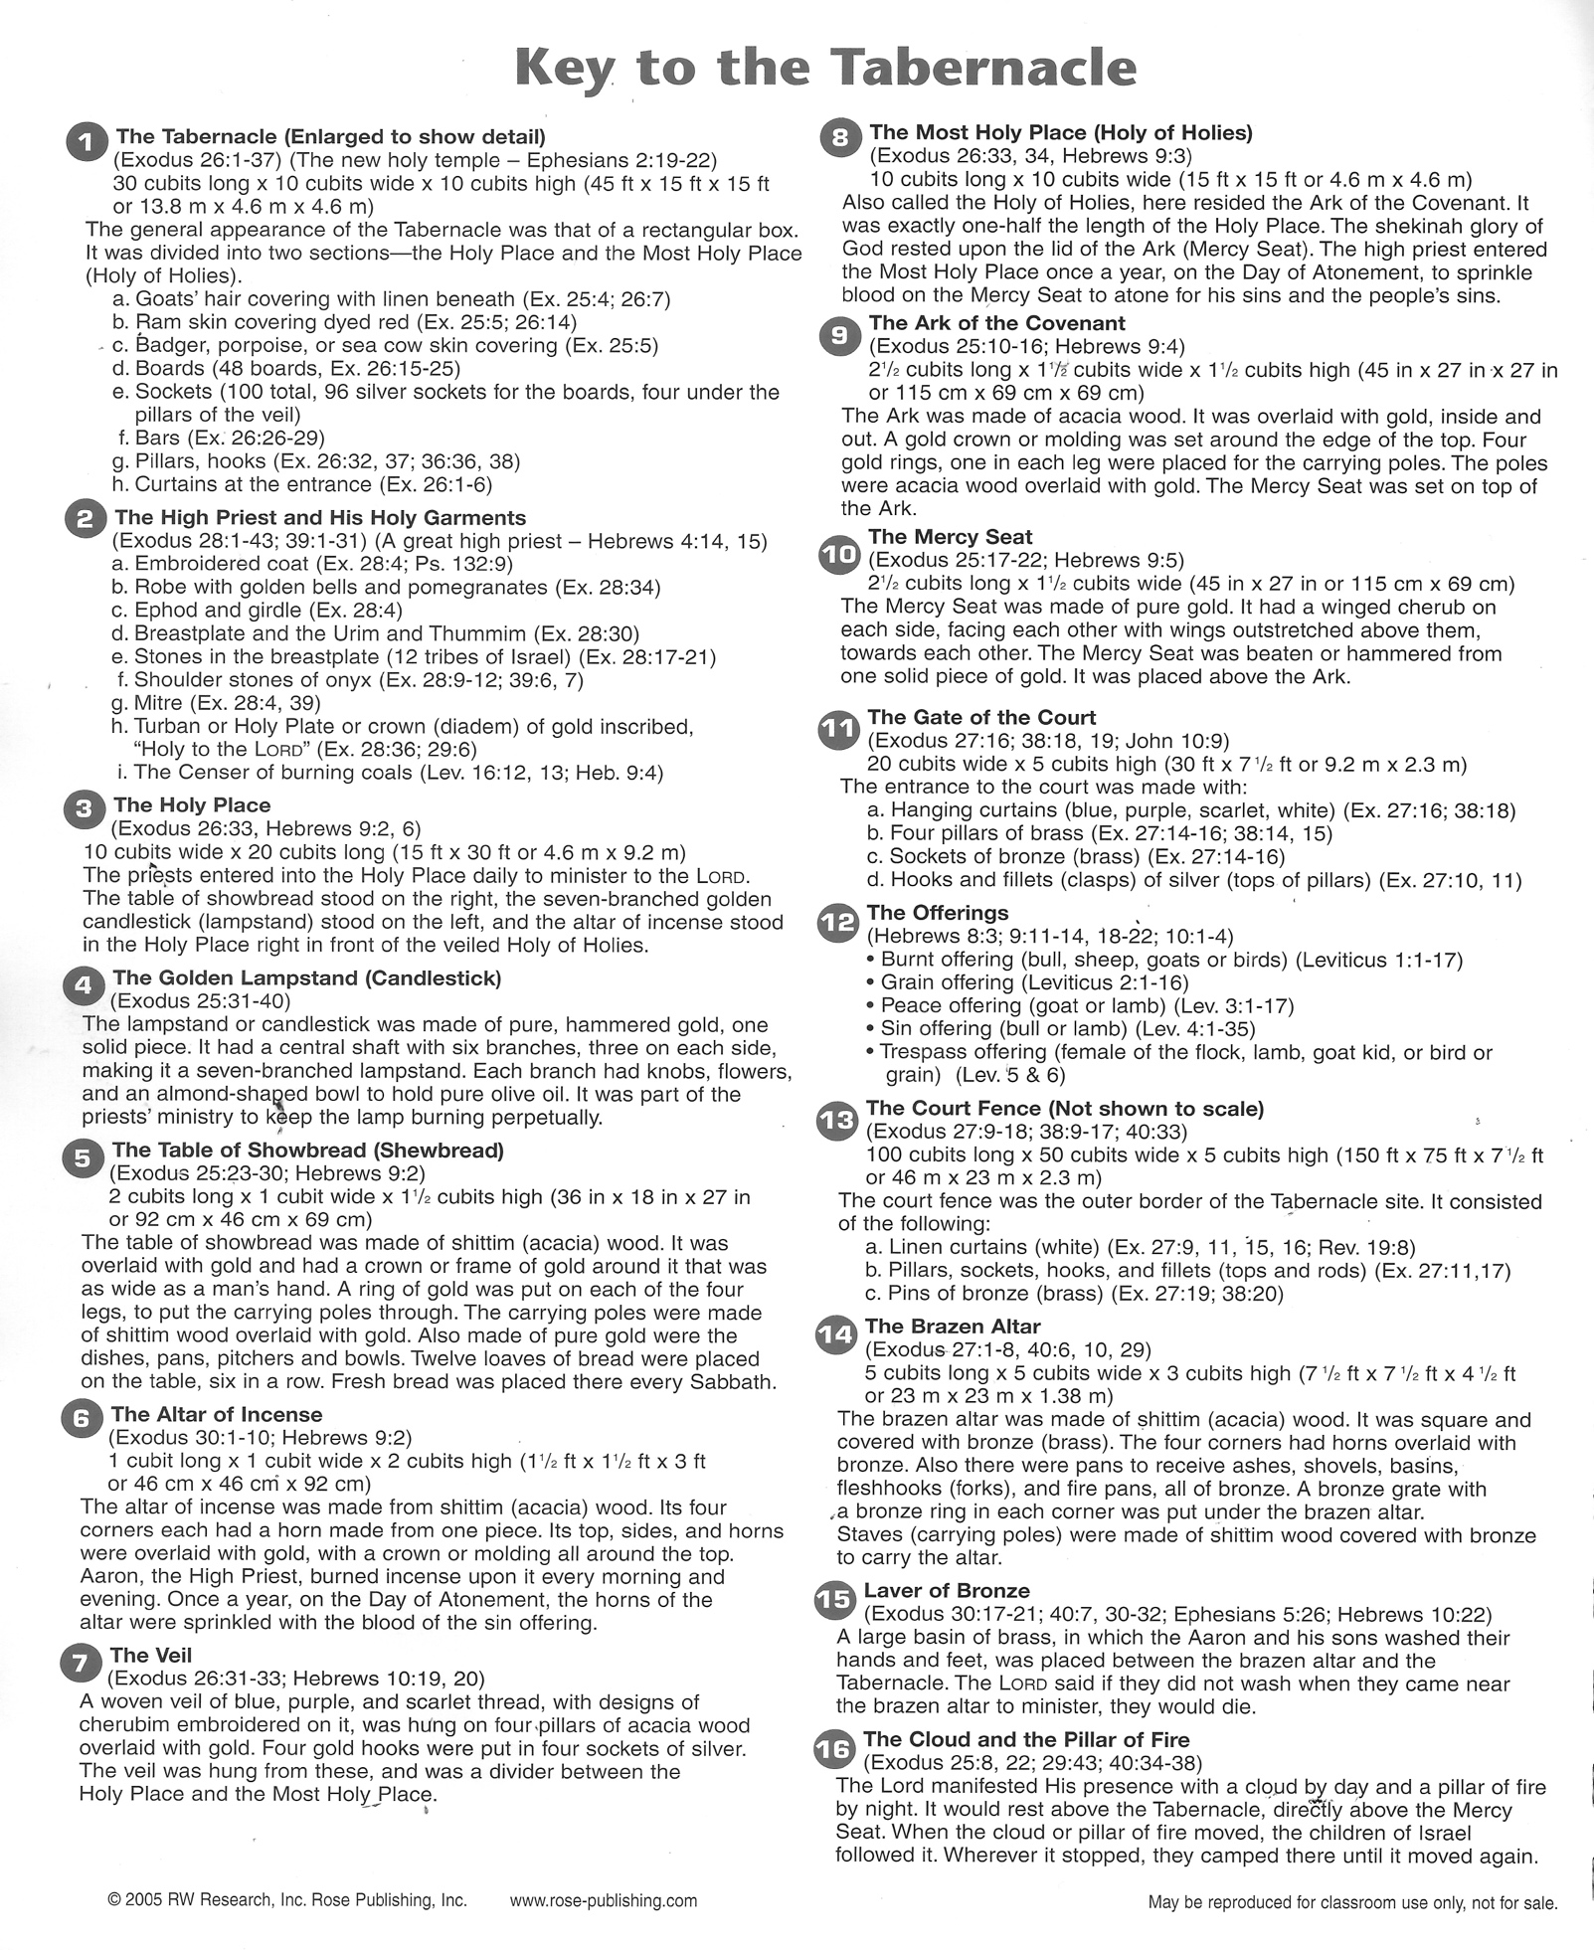

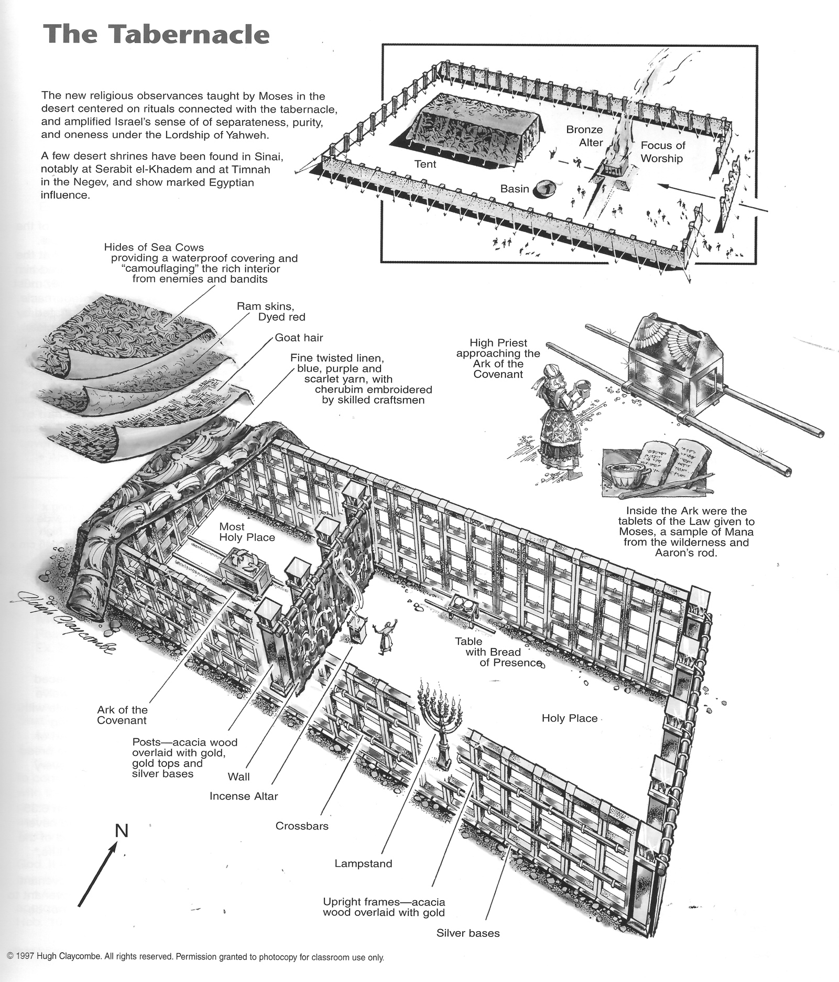

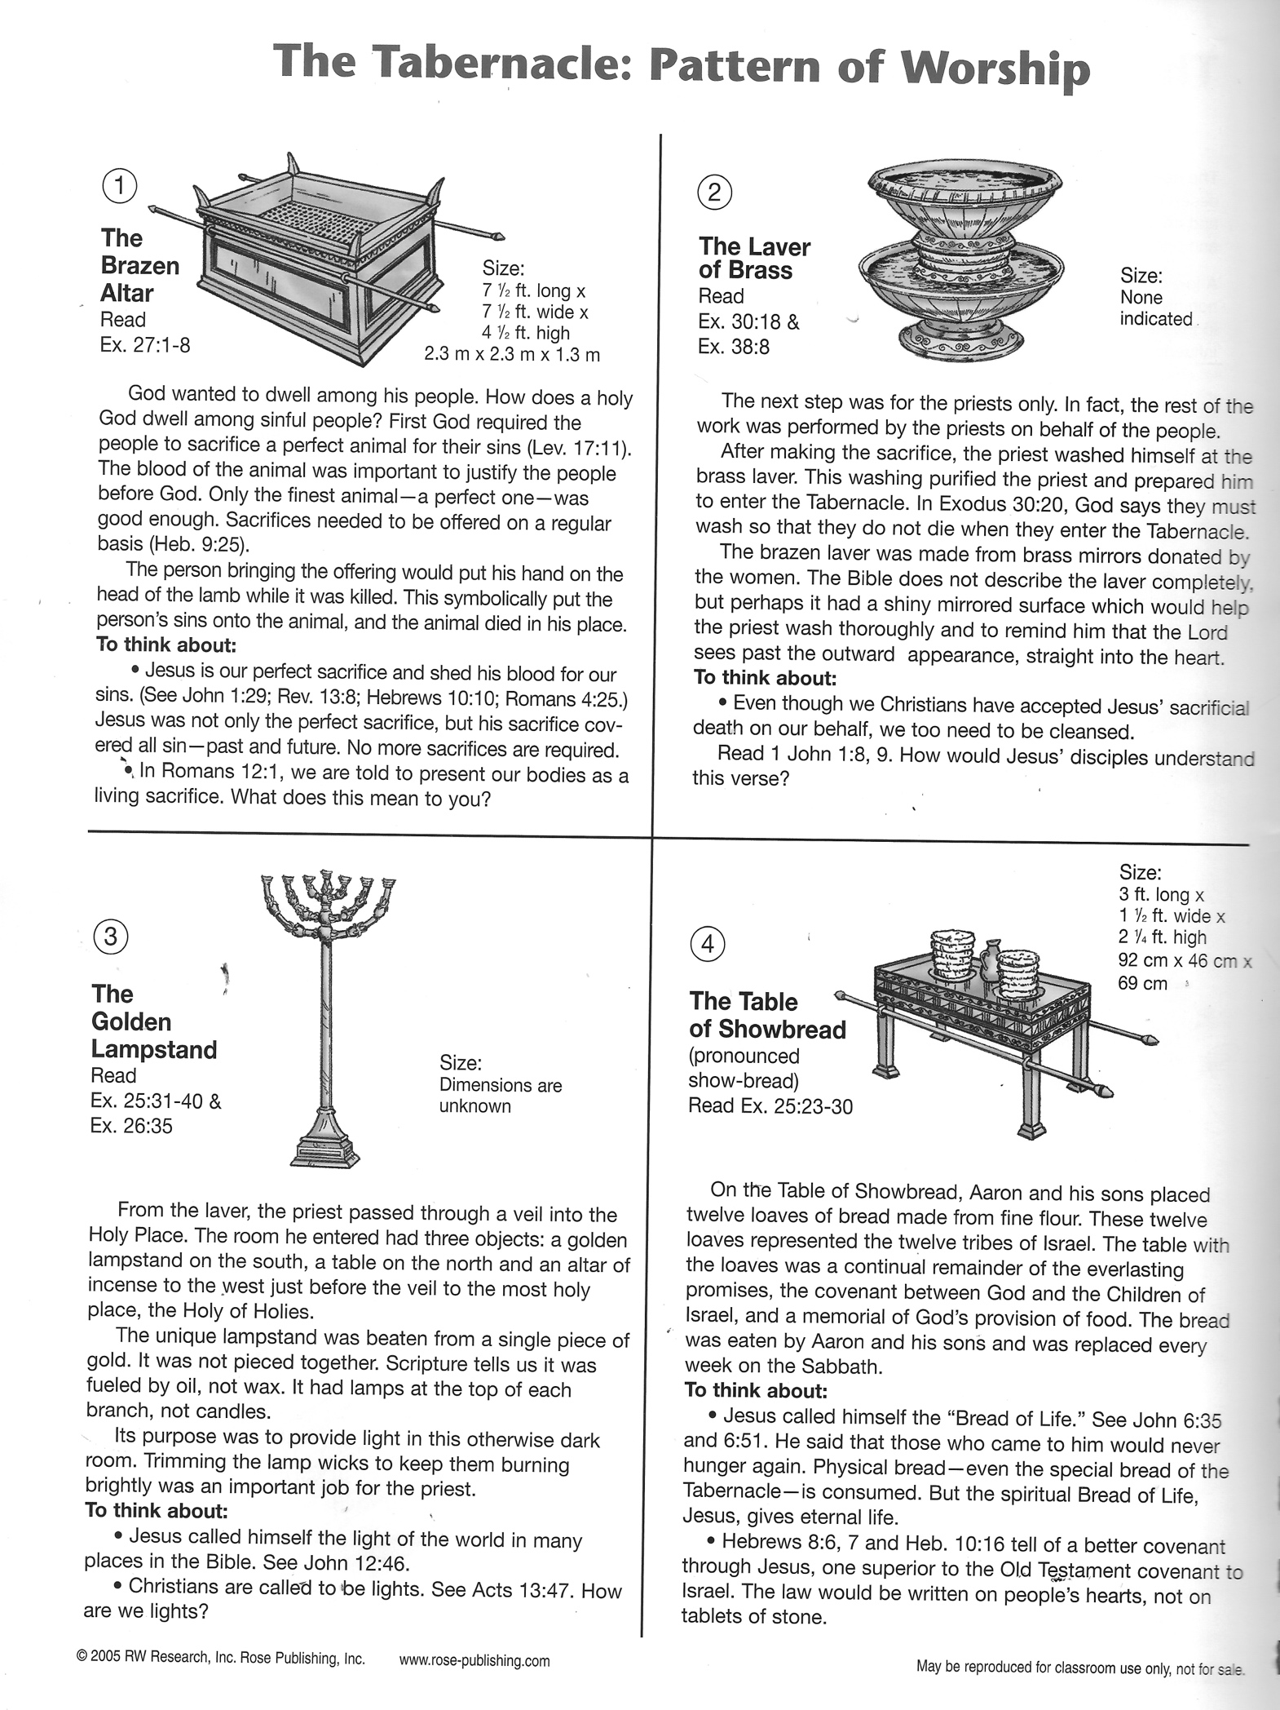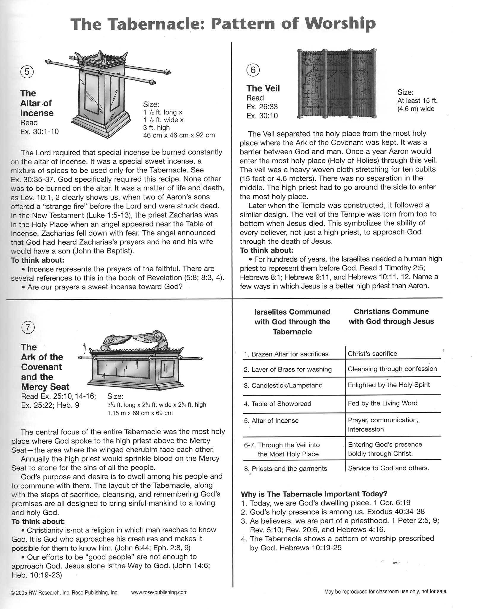

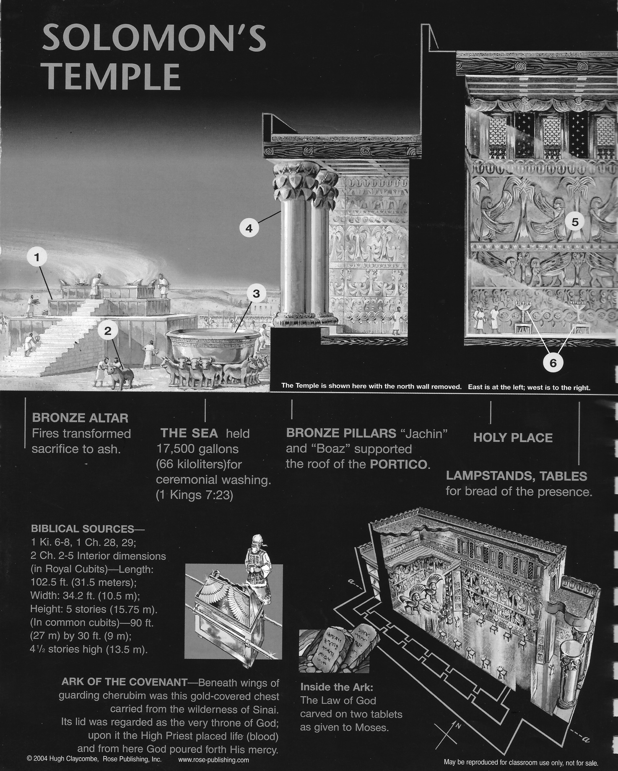

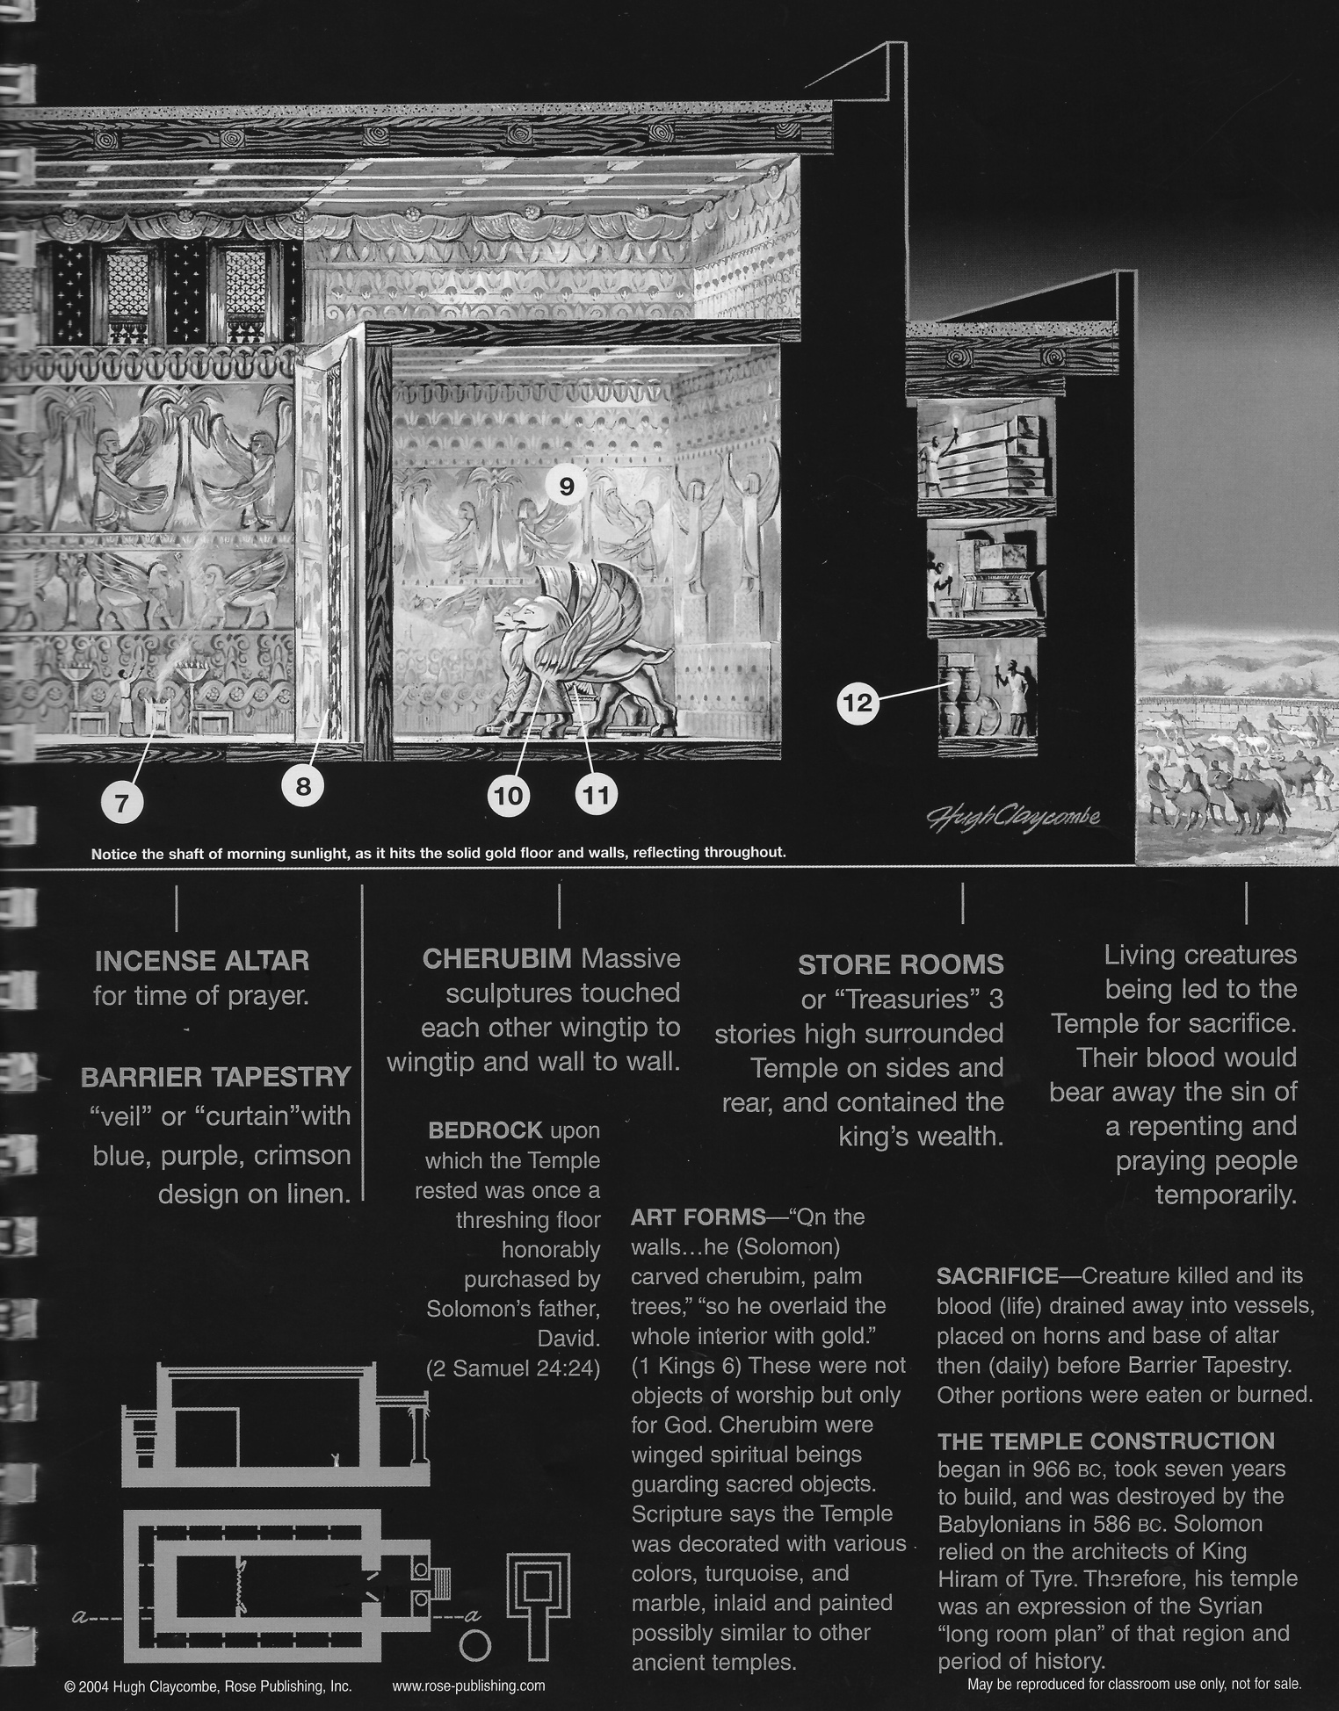

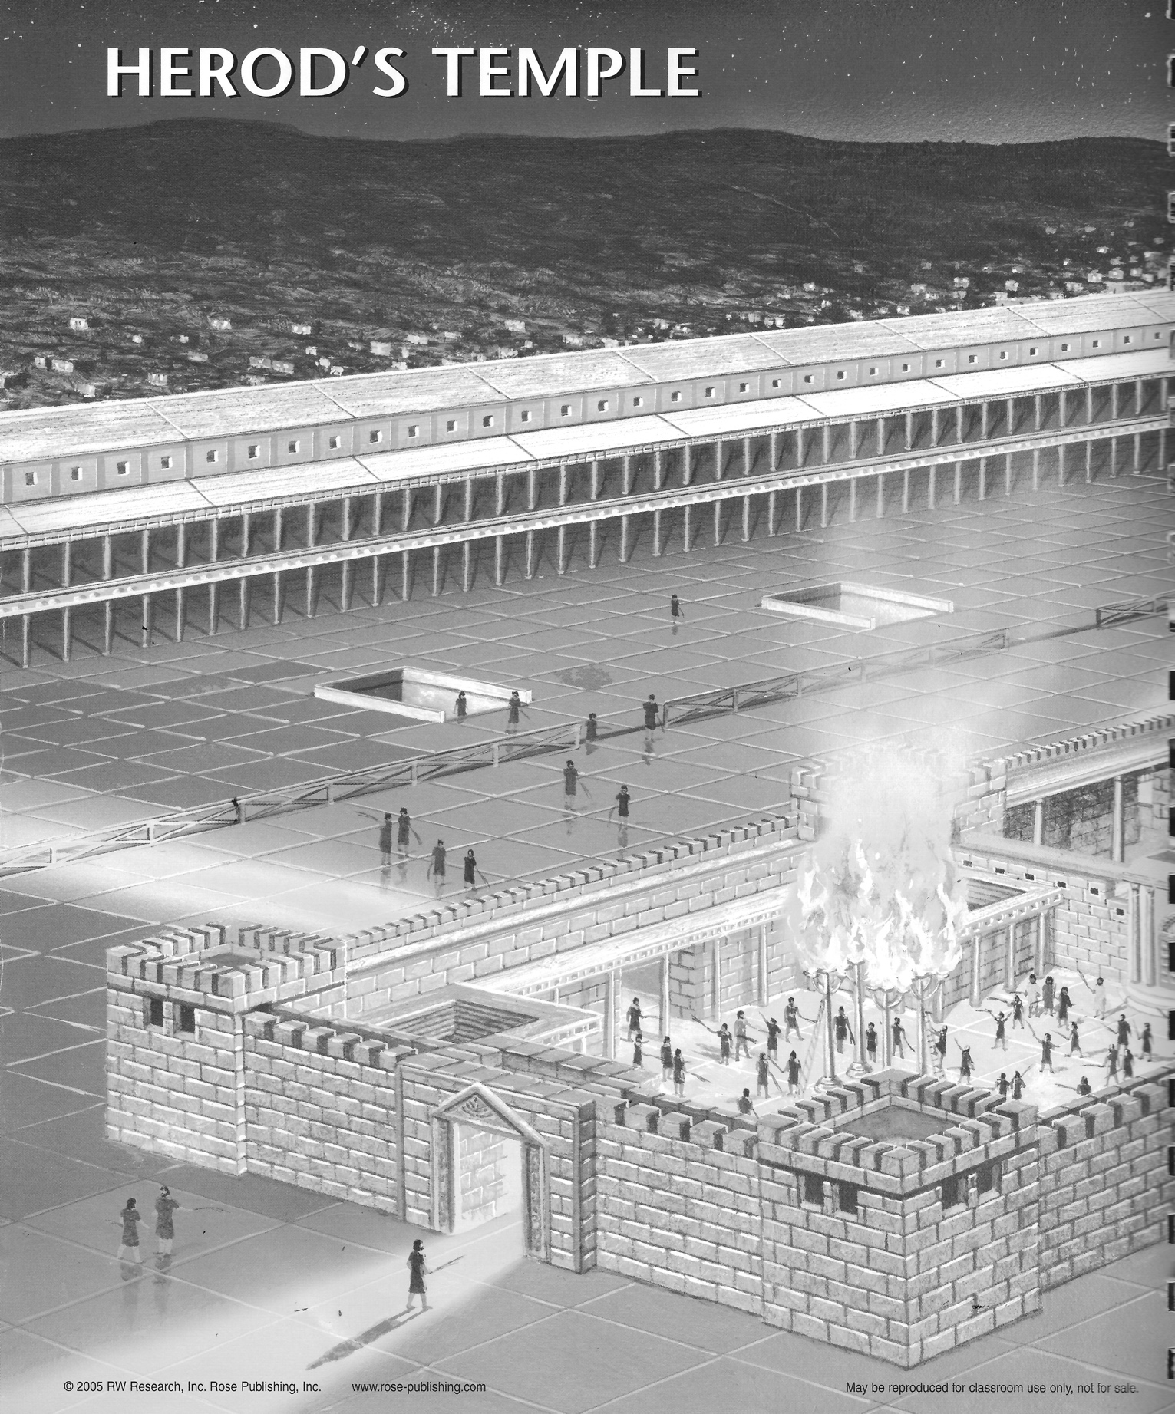

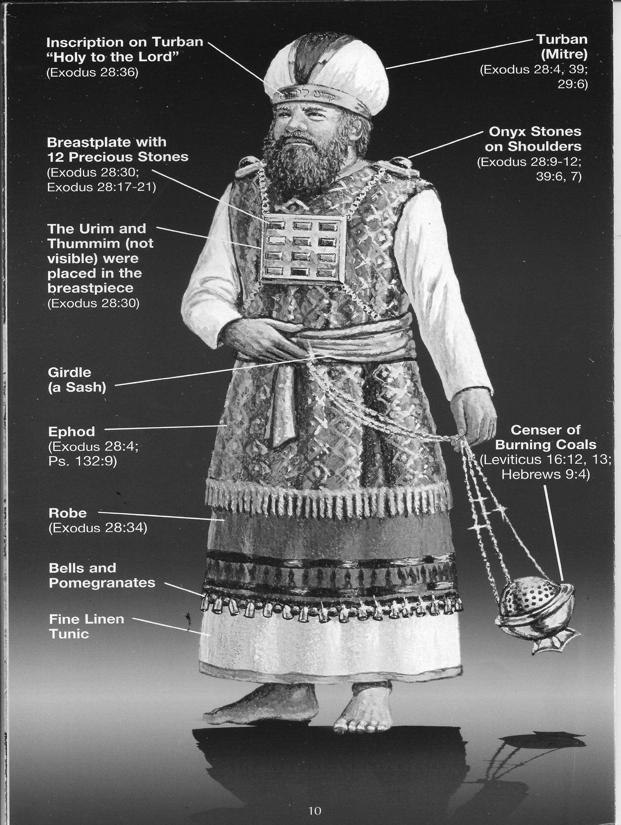

NEHEMIAH’S JERUSALEM

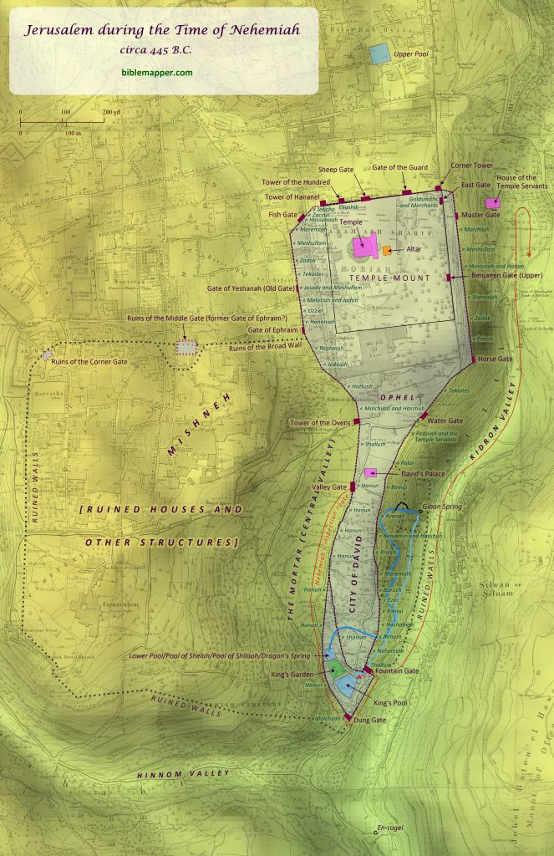
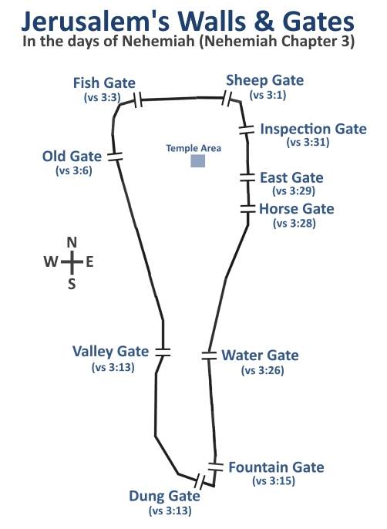

https://jesusplusnothing.com/series/post/nehem3
https://inspiredscripture.com/bible-studies/nehemiah-3#google_vignette&gsc.tab=0

- THE NUMERICAL PRINCIPLE

- Focus
- Numbers in the Bible can have symbolic meaning
- Understanding the meaning behind numbers in the Bible can help us understand the revelation a bit more clearly

- Resources
- Bullinger’s Book of Numbers-- can be found online—
- http://www.biblebelievers.org.au/number01.htm

- Example
- One—symbol of Divinity, Number of God, unity, first
- Two—Number of witness, Testimony,

- Practice
- Find 2 numbers in the Bible and determine their significance

- THE TYPICAL PRINCIPLE
- Focus
- “Biblical types and shadows are a real service, object, event or person that had meaning in and of itself.”
- Merriam-Webster defines a type as a person or thing (as in the Old Testament) believed to foreshadow another (as in the New Testament)
- Biblical types and shadows point to the sovereignty of God and His overall complete plan. Examples are not types

- Resources
- https://www.gotquestions.org/typology-Biblical.html
- https://christiancourier.com/articles/a-study-of-biblical-types
- https://bible.org/illustration/types-bible

- Examples
- Joseph is a type of Christ (son’s relation to the Father)
- Adam in Romans 5:14 is a type of Christ
- Tabernacle of Moses is a type of God’s dwelling place, a type of Christ himself (John 1:14), a type of the church, of the believer (Eph. 3:17), Heaven Sanctuary (Hebrews 8:1-5)

- Practice
- A great example of typology is in Genesis 22 in the person of Issac. He is a picture or representation or type of Christ. Find at least 5 things that demonstrate this idea. https://bible.org/illustration/types-bible

ISAAC AS A TYPE OF CHRIST

EVENT | ISAAC | JESUS
Only begotten Son | Genesis 22:2 | John 3:16
Offered on a mountain, hill | 22:2 | Matt. 21:10
Took donkey to place of sacrifice | 22:3 | Matt. 21:2-11
Two men went with him. | 22:3 | Mark 15:27; Luke 23:33
Three-day journey. Jesus: three days in the grave | 22:4 | Luke 24:13-21
Son carried wood on his back up hill | 22:6 | John 19:17
God will provide for Himself the lamb | 22:8 | John 1:29
Son was offered on the wood | 22:9 | Luke 23:33
Ram in thicket of thorns | 22:13 | John 19:2
The seed will be multiplied | 22:17 | John 1:12; Is. 53:10
Abraham went down, Son didn’t, “not mentioned.” | 22:19 | Luke 23:46
Servant gets bride for son | 24:1-4 | Eph. 5:22-32; Rev. 21:2,9; 22:17
The bride was a beautiful virgin | 24:16 | 2 Cor. 11:2
Servant offered ten gifts to bride* | 24:10 | Rom. 6:23; Rom. 12; 1 Cor. 12

MISCELLANEOUS TOOLS
FOR
BIBLICAL INTERPRETATION

HOURS

Hours (webbible encyclopedia)
1st hour 6am
3rd hour 6-9 am
6th hour 9-12 midday
9th hour 12-3 pm
12th hour 3-6 pm

- First found in Dan. 3:6; 4:19, 33; 5:5It is the rendering of the Chaldee shaah, meaning a “moment,” a “look.” It is used in the New Testament frequently to denote some determinate season (Matt. 8:13; Luke 12:39).
- With the ancient Hebrews the divisions of the day were “morning, evening, and noon-day” (Ps. 55:17, etc.).
- The Greeks, following the Babylonians, divided the day into twelve hours.
- The Jews, during the Captivity, learned also from the Babylonians this method of dividing time. When Judea became subject to the Romans, the Jews adopted the Roman mode of reckoning time. The night was divided into four watches (Luke 12:38; Matt. 14:25; 13:25).
- Frequent allusion is also made to hours (Matt. 25:13; 26:40, etc.).
- An hour was the twelfth part of the day, reckoning from sunrise to sunset, and consequently it perpetually varied in length.

WATCHES
The periods into which the time between sunset and sunrise was divided. They are so called because watchmen relieved each other at each of these periods. There are frequent references in Scripture to the duties of watchmen who were appointed to give notice of the approach of an enemy (2 Sam. 18:24-27; 2 Kings 9:17-20; Isa. 21:5-9). They were sometimes placed for this purpose on watch-towers (2 Kings 17:9; 18:8). Ministers or teachers are also spoken of under this title (Jer. 6:17; Ezek. 33:2-9; Hebrews 13:17).
The watches of the night were originally three in number.
- “the beginning of the watches” (Lam. 2:19);
- “the middle watch” (Judg. 7:19)
- “the morning watch” (Ex. 14:24; 1 Sam. 11:11), which extended from two o'clock to sunrise.
But in the New Testament we read of four watches, a division probably introduced by the Romans (Matt. 14:25; Mark 6:48; Luke 12:38).

Cock-crowing
In our Lord's time the Jews had adopted the Greek and Roman division of the night into four watches, each consisting of three hours, the first beginning at six o'clock in the evening (Luke 12:38; Matt. 14:25; Mark 6:48). But the ancient division, known as the first and second cock-crowing, was still retained. The cock usually crows several times soon after midnight (this is the first crowing), and again at the dawn of day(and this is the second crowing). Mark mentions (14:30) the two cock-crowings. Matthew (26:34) alludes to that only which was emphatically the cock-crowing, viz, the second.

Watches

1st watch 6-9 pm
2nd watch 9-12 pm
Cock-crowing 12-3 am
Morning watch 3-6 am

TIMES AND SEASONS OF THE BIBLE
JEWISH CALENDAR (SACRED—THERE IS ALSO A CIVIL CALENDAR WHERE
TISHRI IS THE FIRST MONTH AND NISSAN IS THE 7TH MONTH)
MONTH | NAME OF MONTH | ACTIVITY | FESTIVAL | EQUIVALENT
1 | NISAN  EARLY NAME ABIB | FLAX HARVEST  BARLEY HARVEST  LUKE 22:13-20; ESTHER 3:7  EXODUS 12:2-37  NEHEMIAH 2:1  RUTH 1:22 | PASSOVER FOLLOWED BY UNLEAVENED BREAD  14TH = PASSOVER  21ST = FIRSTFRUITS | MARCH-APRIL
2 | IYYAR  EARLY NAME ZIV | FLAX AND BARLEY HARVEST  GENERAL HARVEST  1 K. 6:1 | SEVEN WEEKS | APRIL-MAY
3 | SIVAN | GRAIN HARVEST  VINE TENDING  ESTHER 8:9 | HARVEST/WEEKS  (PENTECOST) | MAY-JUNE
4 | TAMMUZ | VINES TENDING  FIRST-RIPE GRAPES  NUMBERS 13:20 | --- | JUNE-JULY
5 | AB | SUMMER FRUIT HARVEST  SUMMER HEAT | --- | JULY-AUGUST
6 | ELUL | GRAPE AND OLIVE HARVEST  GATHERING  NEHEMIAH 6:15  ISAIAH 32:10 | --- | AUGUST-SEPT
7 | TISHRI  EARLY NAME ETHANIM | GRAPE AND OLIVE HARVEST  NEHEMIAH 8  LEV. 16:29-30  LEV. 23:23-25  1 K. 8:2 | 1ST:TRUMPETS  ( NEW YEAR)  10TH: DAY OF ATONEMENT  15TH-21ST TABERNACLES/ BOOTHS/SHELTERS | SEPT-OCT
8 | MARCHESVAN  EARLY NAME BUL | PLOUGHING AND PLANTING  AUTUMN RAINS  GRAIN PLANTING  FIRST RAINS  1 K. 6:38  DEUTERONOMY 11:14 | --- | OCT-NOV
9 | KISLEV | PLOUGHING AND PLANTING  AUTUMN RAINS  JOHN 10:22  ZECH. 7:1  EZRA 10:9 | 25TH:LIGHTS  (TEMPLE AND DEDICATION) | NOV-DEC
10 | TEBET | PLOUGHING AND PLANTING  RAINY SEASON- OCCASIONAL HEAVY RAIN |  | DEC-JAN
11 | SHEBAT | LATE PLANTING  SPRING RAINS  WINTER FIGS | --- | JAN-FEB
12 | ADAR | LATE PLANTING  SPRING RAINS/LATTER RAINS-PULLING FLAX  ESTHER 9:26-28 | PURIM | FEB-MAR

1 | 7 | Nisan  30 days | March/April | 14. Passover (Pesahim)  16. Firstfruits of barley | Fall of the latter spring rains  Barley ripe
2 | 8 | Iyyar  29 days | April/May | 14. Second Passover (Pesahim) | Barley harvest  Wheat ripens
3 | 9 | Sivan  30 days | May/June | 6. Feast of Weeks (Shawu'ot)  Firstfruits of wheat | Wheat harvest.  Begin of the summer  (no rain until September)
4 | 10 | Tammuz  29 days | June/July |  | Heat increases
5 | 11 | Ab  30 days | July/August |  | The streams dry up; heat intense
6 | 12 | Elul  29 days | August/September |  | Vintage  General grape harvest
7 | 1 | Tishri  30 days | September/October | 1. New Year (Rosh Hashanah); Feast of Trumpets  10. Day of Atonement (Yoma)  15-23. Feast of Tabernacles (Sukkah)  Firstfruits of wine and oil | Early rains  Plowing and sowing begins
8 | 2 | Marheshvan  29 days | October/November |  | Continuous rain  Wheat and barley sown  Vintage in Galilee
9 | 3 | Kislev  30 days | November/December | 25. Feast of Dedication (Chanukah) | Begin of winter. Snow on the mountains
10 | 4 | Tebeth  29 days | December/January |  | Coldest month; hail, snow.
11 | 5 | Shebat  30 days | January/February |  | Weather becomes warmer
12 | 6 | Adar  29 days | February/March | 14. Feast of Purim (Megillah) | Thunder and hail frequent  Almond trees blossom
JEWISH CALENDAR

The Jewish calendar is used for religious purposes by Jews all over the world, and it is the official calendar of Israel. The Jewish calendar is a combined solar/lunar calendar. (Zondervan Handbook to the Bible, p. 42-3 & Eerdman’s Handbook to the Bible, p. 114-5)

JEWISH FEASTS AND FESTIVALS (Reproduced from Holman Book of Biblical Charts, Maps, and Reconstructions, 1993, p. 56)

NAME | MONTH: DATE | REFERENCE | SIGNIFICANCE
PASSOVER | NISAN (MAR/APR) | EXODUS 12:2-20  LEV 23:5 | COMMEMORATES GOD’S DELIVERANCE OF ISRAEL OUT OF EGYPT
FEAST OF UNLEAVENED BREAD | NISAN (MAR/APR) | LEV 23:6-8 | COMMEMORATES GOD’S DELIVERANCE OF ISRAEL OUT OF EGYPT. INCLUDES A DAY OF FIRSTFRUITS FOR THE BARLEY HARVEST
FEAST OF WEEKS, OR HARVEST (PENTECOST) | SIVAN (MAY/JUNE) | EXOD 23:16; 34:22  LEV 23:15-21 | COMMEMORATES THE GIVING OF THE LAW AT MOUNT SINAI. INCLUDES A DAY OF FIRSTFRUITS FOR THE WHEAT HARVEST
FEAST OF TRUMPETS  (ROSH HASHANAN) | TISHRI (SEPT/OCT) | LEV 23:23-25  NUM 29:1-6 | DAY OF THE BLOWING OF THE TRUMPETS TO SIGNAL THE BEGINNING OF THE CIVIL NEW YEAR
DAY OF ATONEMENT  (YOM KIPPUR) | TISHRI (SEPT/OCT) | LEV 23:26-33  EXODUS 30:10 | ON THIS DAY THE HIGH PRIEST MAKES ATONEMENT FOR THE NATION’S SIN. ALSO A DAY OF FASTING
FEAST OF BOOTHS  OR TABERNACLES (SUKKOT) | TISHRI (SEPT/OCT) | LEV 23:33-43  NUM 29:12-39  DEUT 16:13 | COMMEMORATES THE 40 YEARS OF WILDERNESS WANDERING
FEAST OF DEDICATION, OR FEAST OF LIGHTS (HANUKKAH | KISLEV (NOV/DEC)  AND TEBETH (DEC/JAN) | JOHN 10:22 | COMMEMORATES THE PURIFICATION OF THE TEMPLE BY JUDAS MACCABAEUS IN 164 BC
FEAST OF PURIM OR ESTHER | ADAR (FEB/MAR) | ESTHER 9 | COMMEMORATES THE DELIVERANCE OF THE JEWISH PEOPLE IN THE DAY OF ESTHER

MEASURES AND MONEY

A. MEASURES OF TIME

Year -Years were based on the changing of the seasons. Before the use of BC and AD- a year was linked to a king’s reign. B.C. is an abbreviation for “Before Christ.” A.D. is an abbreviation for “anno Domini,” which is Latin for “in the year of our Lord.” Dionysius Exiguus, a monk, invented the B.C./A.D. method during the Middle Ages, early in the sixth century.

Month -Months were based on the phases of the moon. The first month was Nisan in which Passover was celebrated (Lev. 23:5)

Week- The interval between two Sabbaths

Sabbath -The 7th day of the week which is Saturday. The first day of the week was Sunday (Luke 24:1), the day which early Christians met together (Acts 20:7)
Day- A 24 hour period based on the day-night cycle. Jews calculated the day from sunset to sunset (Lev. 23:32)

Hour- for the Jews the hours of a day started at 6 am

Named hours
- Third hour was 9 am (Mark 15:25; MT 20:3; Acts 2:15; 23:23)
- Sixth hour was about midday (MT. 20:5-6; MT 27:45; Mark 15:33; Luke 1:26)
- Seventh hour was about 1 pm (John 4:52)
- Ninth hour was about 3 pm (MT 20:5; Mark 15:33-34; Luke 23:44)
- Tenth hour was about 4 pm (John 1:39)
- Eleventh hour was about 5 pm (MT 20:6,9)

Parts of the day
- Cock-crowing signified two times: one was after midnight, and one was before dawn (Mark 14:30)
- Cool of the day was from about 2 pm to 6 pm (Genesis 3:8)
- Heat of the day was about 10 am to 12 pm (Genesis 18:1)

The watches of the day and night- a watch lasted about 3 hours

New Testament watches
- First watch lasted from 6 pm to 9 pm
- Second watch lasted fro 9 pm to midnight (Luke 12:38)
- Third watch lasted from midnight to 3 am (Luke 12:38)
- Fourth watch lasted from 3 am to 6 am (MT 14:25)

Old Testament watches
- First watch lasted from 9 pm to midnight
- Beginning of the watches was about 9 pm (Lamentations 2:19)
- Middle watches lasted from midnight to 3 am (Judges 7:19)
- Morning watch lasted from 3 am to 6 am (Exodus 14:24)

B. MEASURES OF WEIGHT AND MONEY (AMG’s Encyclopedia of Bible Facts, 2004)
Weight
- Shekel- Most basic unit of weight among the Hebrew people (often when bible speaks of pieces of silver – it is referring to shekels of silver)
- Talent- The largest measure of weight used by the Hebrews. One talent was equal to about 3000 shekels. (About as much as anyone could carry. (2 K. 5:23). Talent weight was used for metals:
- Gold (1 K. 9:14)
- Silver (2 K. 5:22)
- Lead (Zech. 5:7)
- Bronze (Exodus 38:29)
- Iron (1 Chronicles 29:7)

Money
- Dram (1 Chronicles 29:7; Ezra 8:27; Ezra 2:69)
- Farthing- a bronze coin was the smallest Roman coin in use. One farthing was equal to two mites Sixty-four farthings was equal to one denarius (MT 12:42; MT 10:29)
- Mite-was the smallest Jewish coin in use (Luke 21:2; Mark 12:42; Luke 12:59; Luke 21:2)
- Four-drachma coin was a tribute money or a temple tax (MT 17:27)

Measures of length
- American mile = 5280 feet or 1760 yards; yard = 3 feet; foot = 12 inches
Handbreadth was the width of the four fingers closely pressed together, about 3-4 inches (Exodus 37:12)
Cubit was the length of the arm from the point of the elbow to the end of the middle finger, about 18 inches. Goliath’s height in 1 Samuel 17:4 = 6 cubits and a span. 6x18 = 108 inches about 9feet and 9 inches tall
Span is the distance from the end of the thumb to that of the little finger, about 9 inches
Measuring reed was a plant (calamus or sweet cane) from which it’s shape and length was used as a measure. (Ezekiel 40: 3, 5)

Measures of distance
- Furlong measured about 600 feet (John 6:19)
- Sabbath day’s journey was based on the instruction in exodus 16:29 which was to be no longer that 5 furlongs, about ½ mile (Acts 1:12)
- A day’s journey was the distance a person could travel in one day about 20-30 miles individually and about 10 miles as a group (Luke 2:44)

Measures of capacity
- American dry measures= bushel = 4 pecks, peck= 8 quarts, quart=2 pints
- Handful refers to the capacity of the hand (Lev 2:2)
- Omer was about 5 pints (Exodus 16:6)
- Ephah was equal to 10 omers (Exodus 16:36)
- American liquid measures = gallon= 4 quarts, quart= 2 pints
- Log is less than ½ pint (Lev. 14:10)
- Hin is nearly 6 pints (Exodus 29:40)
- Bath was the largest liquid measure used by the Jews in the OT. A bath was about 7 gallons (1 K. 7:26)
- Firkin was about 9-10 gallons (John 2:6)
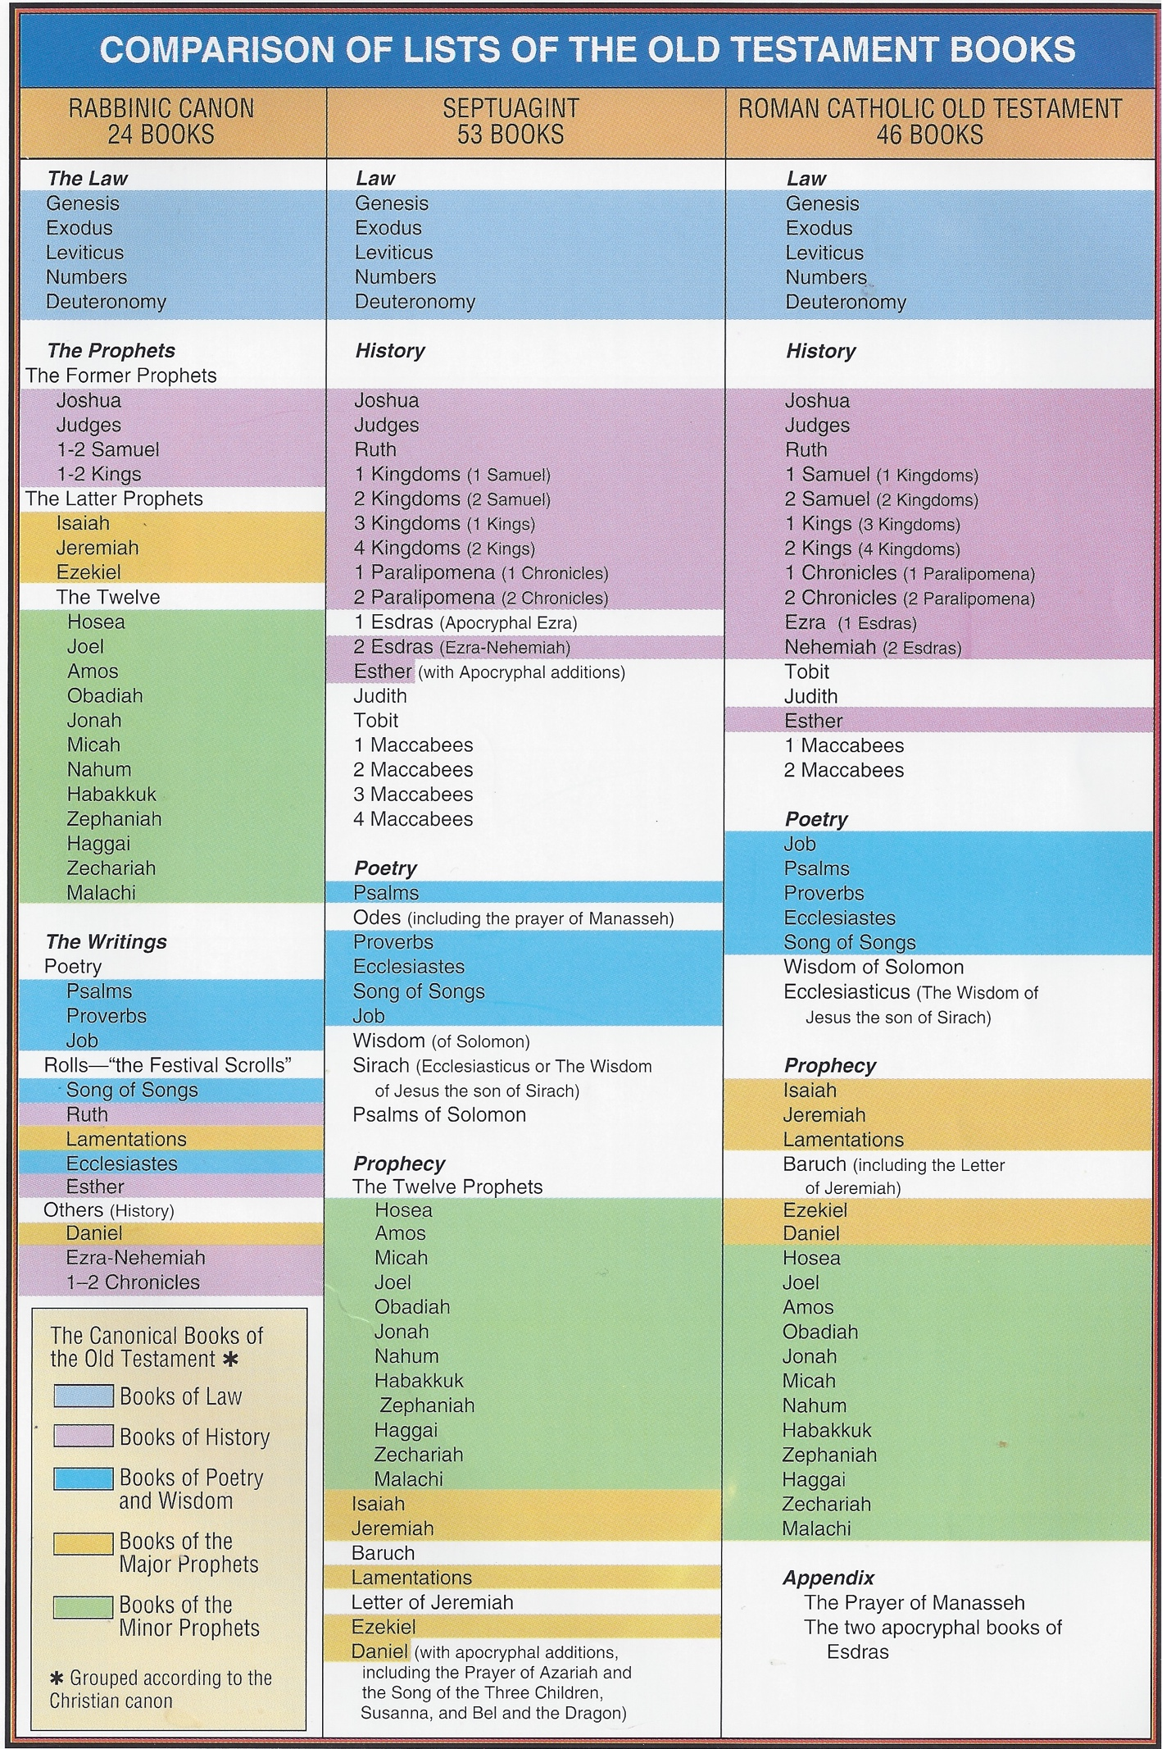
THE BIBLE IS ORGANIZED
OLD TESTAMENT | BOOKS | NEW TESTAMENT | BOOKS
PENTATEUCH-(TORAH) | GENESIS  EXODUS  LEVITICUS  NUMBERS  DEUTERONOMY | GOSPELS | MATTHEW  MARK SYNOPTIC “see the same”  “optic= to see”  LUKE  JOHN
HISTORY | JOSHUA  JUDGES  RUTH  1&2 SAMUEL  1&2 KINGS  1&2 CHRONICLES  EZRA  NEHEMIAH  ESTHER | HISTORY | ACTS
POETRY & WISDOM | JOB  PSALMS  PROVERBS  ECCLESIASTES  SONG OF SOLOMON | LETTERS (EPISTLES) | ROMANS  1&2 CORINTHIANS  GALATIANS  EPHESIANS  PHILIPPIANS  COLOSSIANS  1&2 THESSALONIANS  1&2 TIMOTHY  TITUS  PHILEMON  HEBREWS  JAMES  1&2 PETER  1,2, 3rd JOHN  JUDE
THE PROPHETS (MAJOR- THE TERM "MAJOR" REFERS TO THEIR LENGTH, NOT THEIR IMPORTANCE.) | ISAIAH  JEREMIAH  LAMENTATIONS  EZEKIEL  DANIEL | APOCOLYPTIC (REVELATION) | REVELATION
THE PROPHETS (MINOR) | HOSEA  JOEL  AMOS  OBADIAH  JONAH  MICAH  NAHUM  HABAKKUK  ZEPHANIAH  HAGGAI  ZECHARIAH  MALACHI

PSALMS

The book of Psalms is a collection of 150 poems, hymns, and songs originating from worship in ancient Israel. Throughout history, church fathers and Bible scholars have classified individual psalms into various categories according to their content, theme, and structure.

5 BOOKS
Book 1: Psalms 1—41
Book 2: Psalms 42—72
Book 3: Psalms 73—89
Book 4: Psalms 90—106
Book 5: Psalms 107—150

Each of these five books or sections of Psalms ends with a doxology or a song of praise. The final verse of each concluding psalm includes either “Praise the Lord!” or “Amen.” For example, the final verse of Psalm 41 ends this way: “Praise be to the Lord, the God of Israel, / from everlasting to everlasting. / Amen and Amen.” Psalm 150, the final psalm, serves as the fitting final doxology, concluding with the words, “Let everything that has breath praise the Lord. / Praise the Lord.”

MESSIANIC PSALMS
Psalms that anticipated the coming of the Messiah.
The sixteen psalms are: Psalms 2, 8, 16, 22, 24, 40, 41, 45, 68, 69, 72, 89, 91, 102, 110, 118.

PENITENTIAL PSALMS OR PSALMS OF CONFESSION
There are seven penitential psalms: Psalms 6; 32; 38; 51; 102; 130; and 143.
The most familiar penitential psalm, Psalm 51, has been called the Sinner’s Guide.
It is King David’s prayer of repentance after the prophet Nathan confronted him with his sins (2 Samuel 12). David had committed adultery with Bathsheba and covered it up by having her husband, Uriah, killed. The words of Psalm 51 pour forth from David’s darkest moment of self-awareness. He acknowledges the depth of his sin and guilt and pleads for God’s mercy. Then, gripped with confidence in God’s faithfulness, David believes his plea will be heard and answered. Psalm 32, the follow-up to this psalm, reveals that God does indeed grant David’s prayer. Besides serving as a personal prayer of confession, contrition, and restoration, Psalm 51 also gives voice to the nation of Israel in its plea for repentance and salvation.

PSALMS OF ASCENT – JOURNEY PSALMS- SONG OF DEGREES
The 15 Psalms of Ascent(s) have also been called the Song of Degrees, the Pilgrim Songs, as well as the Gradual Psalms. They are named this because of the phrase appearing before each psalm in Psalms 120-134. Each is called “a song of ascent” at the beginning of the psalm. The What does ascent refer to? The word itself can refer to steps as well as to a pilgrimage ascent. This has led some to believe that the fifteen psalms are representative of the fifteen steps leading up to the temple in Jerusalem. Most scholars, though, believe that the ascent is referring to the Israelites pilgrimage during the three annual feasts (see Deuteronomy 16:16). Jerusalem, positioned on a hill, meant that any surrounding villagers would have to be “going up” in order to worship at the temple. Others also see this as an ascent back to Jerusalem from exile. O. Palmer Robertson is likely correct in seeing a combination of these options:
Hebrew term is maʿalot which means “going up.”

HALLELUYAH PSALMS
Psalms 146-150 ---Each psalm in this five-psalm group both begins and ends with an exclamatory “Praise ye the LORD,” or, in the Hebrew, “Hallelujah!”
This word occurs 22 times in the book of Psalms. This is significant in that the Hebrew language has just 22 letters, suggesting to us that the very purpose of language is for God to reveal His Word to man and for man then to respond with thanksgiving and praise to God.

PSALMS 119 ACROSTIC
Each stanza is 8 verses and each stanza begins with a letter of the alephbet. , Psalm 119 is the longest single chapter in the Bible. The author of Psalm 119 is unknown, but most scholars agree that it was written by David, Ezra, or Daniel.
Containing 176 verses, Psalm 119 is the longest single chapter in the Bible. The author of Psalm 119 is unknown, but most scholars agree that it was written by David, Ezra, or Daniel. The format of Psalm 119 is an alphabetic acrostic, meaning that the first letters of each line in Hebrew follow through the alphabet, 8 lines per letter, thus 8 lines x 22 letters in Hebrew = 176 lines.

One prominent theme in Psalm 119 is the profound truth that the Word of God is all-sufficient. Psalm 119 is an expansion of Psalm 19:7–9:
Notice these attributes of God ascribed to Scripture
1. Righteousness (verses 7, 62, 75, 106, 123, 138, 144, 160, 164, 172)
2. Trustworthiness (verse 42)
3. Truthfulness (verses 43, 142, 151, 160)
4. Faithfulness (verse 86)
5. Unchangeableness (verse 89)
6. Eternality (verses 90,152)
7. Light (verse 105)
8. Purity (verse 140)

The terms used as synonyms for the Bible in this psalm convey the concept of authority:
(1) Law (v. 1; the main synonym, used 25x in this psalm) has the nuance of “teaching”; it can refer to a single command, to the first five books of Moses, or to all of Scripture (John 15:25; 1 Cor. 14:21). The law reveals God’s will for how His people are to live. Since it comes from God the law is not just for academic interest, but for obedience.
(2) Testimonies (v. 2; used 10x in the psalm), from a root meaning “to bear witness.” It points to the dependability of the Bible as a witness of things of God. It also has the nuance of warning.
(3) Ways (v. 3; used 7x of God’s ways in this psalm) refers to God’s characteristic manner of acting, as contrasted with our ways (119:5, 26, 29, 59, 168).
(4) Precepts (v. 4; 21x in the psalm) comes from a word meaning to oversee or pay close attention to a matter. Thus it “points to the particular instructions of the Lord, as of one who cares about detail” (Derek Kidner, Psalms [IVP], 2:418).
(5) Statutes (v. 5; 22x in the psalm) comes from a word meaning “to engrave in stone” and thus they “speak of the binding force and permanence of Scripture” (Kidner).
(6) Commandments (v. 6, 22x in the psalm) points to “the straight authority of what is said” (Kidner). It has the idea of giving orders.
(7) Judgments or ordinances (NASB, vv. 7, 13, same Hebrew word; 23x in the psalm) has the idea of justice rooted in God’s character. These are “the decisions of the all-wise Judge about common human situations” (Kidner).
(8) Word (v. 9; 23x in the psalm) is the most general term of all, emphasizing the fact that God has spoken.
(9) Word (v. 11; 19x in the psalm) is similar to the previous term. It is derived from the verb “to say” and may sometimes have the nuance of promise (NASB margin, vv. 38, 41).
(10) Faithfulness (v. 90), righteousness (v. 40), and name (v. 132) are also sometimes cited as synonyms for the Scriptures in this psalm.

https://www.gotquestions.org/penitential-psalms.html
https://www.biblestudytools.com/bible-study/topical-studies/finding-encouragement-for-our-journey-in-the-psalms-of-ascent.html
https://bible.org/seriespage/psalm-119-priority-god’s-word

SALVATION
ACTS 16:31
³¹ And they said, Believe on the Lord Jesus Christ, and thou shalt be saved, and thy house.

*** The study of Salvation is called Soteriology.. The Doctrine of Salvation

1. WHAT IS MEANT BY SALVATION / SAVE IN THE NEW TESTAMENT?
- Comes by Grace through faith in Jesus Christ
- John 1:12
- Ephesians 2:8-9
- GREEK WORD FOR SALVATION
SOTERIA (NOUN) S# GK4991 to deliver or to save
  - Luke 1:71
  - Acts 16:17
  - Hebrews 5:9
SOTERION (ADJECTIVE) S# GK4992
- Luke 2:30
- Acts 28:28

- GREEK WORD FOR SAVE/SAVED
SOZO S# GK4982
- Matthew 10:22
- Luke 8:12
- 1 Timothy 2:4

- SOZO DEFINED
- 1.“to save, i.e. deliver or protect
{literally or figuratively}
properly, deliver out of danger and into safety; used principally of God rescuing believers from the penalty and power of sin – and into His provisions (safety). Deliverance, rescue from sin and the consequences of sin
- 2. heal, be made whole
- 3. Restoration of a broken relationship between a Holy God and a sinful people

- THREE BASIC MEANINGS

- FORGIVEN
- Romans 5:9
9 Much more then, being now justified by his blood, we shall be saved from wrath through him.

- HEALED PHYSICALLY
- Matthew 9:21-22
21 For she said within herself, If I may but touch his garment, I shall be whole.
22 But Jesus turned him about, and when he saw her, he said, Daughter, be of good comfort; thy
faith hath made thee whole. And the woman was made whole from that hour.

- DELIVERED FROM DANGER
- Acts 27: 20, 31
20 And when neither sun nor stars in many days appeared, and no small tempest lay on us, all hope
that we should be saved was then taken away.
31 Paul said to the centurion and to the soldiers, Except these abide in the ship, ye cannot be saved.

- SOZO” challenges us to view salvation as not only a future hope but as an ongoing journey of becoming whole in Christ. Both physical and spiritual

- The THREE TENSES OF SALVATION-- Has the sense of past, present, and future. Saved, being saved, and will be saved. Yesterday, today and tomorrow (forever).

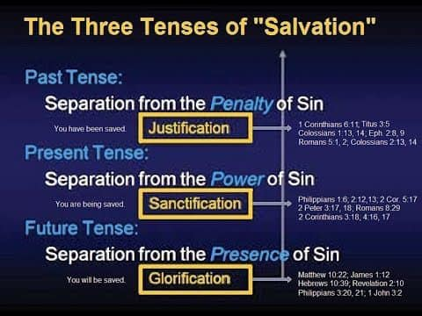

CONSIDER ISAIAH 12

1 And in that day thou shalt say, O LORD, I will praise thee: though thou wast angry with me, thine anger is turned away, and thou comfortedst me.
2 Behold, God is my salvation; I will trust, and not be afraid: for the LORD JEHOVAH is my strength and my song; he also is become my salvation.
3 Therefore with joy shall ye draw water out of the wells of salvation.
4 And in that day shall ye say, Praise the LORD, call upon his name, declare his doings among the people, make mention that his name is exalted.
5 Sing unto the LORD; for he hath done excellent things: this is known in all the earth.
6 Cry out and shout, thou inhabitant of Zion: for great is the Holy One of Israel in the midst of thee.

2. WHAT IS MEANT BY SALVATION IN THE OLD TESTAMENT?
- Since Jesus is the WAY to Salvation in John 14:6, then what THE WAY before Jesus?
- The Path of Righteousness. Follow the Way of Jesus. He is the Pathway.
- Psalms 25:4-5
4 Shew me thy ways, O LORD; teach me thy paths.
5 Lead me in thy truth, and teach me: for thou art the God of my salvation; on thee do I wait all the day.
- Acts 4:12
12 Neither is there salvation in any other: for there is none other name under heaven given among men, whereby we must be saved.
- The Law of the OT could not save. The purpose of the Law in the OT served as a tutor, schoolmaster or guardian. S# GK 3807.
- Galatians 3:24
24 Wherefore the law was our schoolmaster to bring us unto Christ, that we might be justified by
faith.
- Galatians 3:11 tells us whereby Paul is quoting Habakkuk 2:4.
- 11 But that no man is justified by the law in the sight of God, it is evident: for, The just shall live by faith.
- Habakkuk 2:4
4 Behold, his soul which is lifted up is not upright in him: but the just shall live by his faith.

- So, if the LAW could not save how were people of the OT saved? Salvation was received in the OT by faith. Abraham lived hundreds of years before the law was given! So it was by faith that he was saved.
- Genesis 15:6
6 And he believed in the LORD; and he counted it to him for righteousness.
- Romans 4:3
3 For what saith the scripture? Abraham believed God, and it was counted unto him for
righteousness.
- Scripture shows that David also was saved by faith.
  - Romans 4: 6-8
6 Even as David also describeth the blessedness of the man, unto whom God imputeth
righteousness without works,
7 Saying, Blessed are they whose iniquities are forgiven, and whose sins are covered.
8 Blessed is the man to whom the Lord will not impute sin.
- Psalms 32:1-2
1 A Psalm of David, Maschil. Blessed is he whose transgression is forgiven, whose sin is covered.
2 Blessed is the man unto whom the LORD imputeth not iniquity, and in whose spirit there is no guile.
“In Romans 4:23-24 he writes, “The words ‘it was credited to him’ were written not for him alone, but also for us, to whom God will credit righteousness—for us who believe in him who raised Jesus our Lord from the dead.” In other words, righteousness is “credited” or given to those who have faith in God—Abraham, David, and we all share the same way of salvation.” https://www.gotquestions.org/Old-Testament-salvation.html
23 Now it was not written for his sake alone, that it was imputed to him;
24 But for us also, to whom it shall be imputed, if we believe on him that raised up Jesus our Lord
from the dead;
- HEBREW WORD FOR SALVATION IN OLD TESTAMENT
YESHUAH S# H3444
  - Means salvation, deliverance, victory, something saved
  - Isaiah 12:2
2 Behold, God is my salvation; I will trust, and not be afraid: for the LORD JEHOVAH is my strength
and my song; he also is become my salvation.
*GOD IS MY YESHUAH! YESHUAH IS THE HEBREW WORD FOR THE GREEK WORD JESUS!

- HEBREW WORD FOR SAVE IN THE OLD TESTAMENT
YASHA S# H3467
- Means avenging, defend, deliverer, help, preserve, rescue, be safe,
  - Exodus 2:17
17 And the shepherds came and drove them away: but Moses stood up and helped them, and watered their flock.
  - Deuteronomy 22:27
27 For he found her in the field, and the betrothed damsel cried, and there was none to save her.
  - Deuteronomy 33: 29
29 Happy art thou, O Israel: who is like unto thee, O people saved by the LORD, the shield of thy help, and who is the sword of thy excellency! and thine enemies shall be found liars unto thee; and thou shalt tread upon their high places.

- CRUCIAL ELEMENTS FOR SALVATION
- THE BASIS for salvation is GRACE
- The INSTRUMENT of salvation is FAITH
- THE RESULT of salvation is GOOD WORKS
- THE CONFIDENCE of salvation is “WHAT GOD STARTED HE WILL FINISH”

https://jdgreear.com/four-crucial-elements-of-salvation/

3. WHAT IS SIN?
- WORDS TO DESCRIBE SIN IN BIBLE
- OLD TESTAMENT
  - 6 nouns and 3 verbs to describe sin
  - S# H2403 Chatta’ah- an offense, sin, sinner, sin offering, punishment of sin

- NEW TESTAMENT
  - 33 words for sin or the acts of sin
  - S# GK 266- Hamartia—to miss the mark- not hitting the target
- A CONDITION OF THE HEART THAT SEPARATES US FROM GOD
- TRANSGRESSION OF THE LAW OF GOD
- 1 John 3:4
4 Whosoever committeth sin transgresseth also the law: for sin is the transgression of the law.
- REBELLION AGAINST GOD
- DT 9:7
7 Remember, and forget not, how thou provokedst the LORD thy God to wrath in the wilderness: from
the day that thou didst depart out of the land of Egypt, until ye came unto this place, ye have been
rebellious against the LORD.
- Sin is not just bad behavior, it is rebellion against God’s authority. It separates us from him.

4. TYPES OF SIN
- ORIGINAL SIN - ADAMIC NATURE- THE FLESH- SIN NATURE- INHERITED SIN
- Adam and Eve - ate the fruit from the TREE OF KNOWLEDGE AND GOOD AND EVIL
  - Genesis 3
- Inner nature was transformed – our sinful nature enslaves us to sin. The sinful tendencies, desires, and dispositions in our hearts with which we are all born.
- We all enter the world with a fallen nature therefore sin is inherit in us We naturally love sin
    - Psalms 51:5 –
5 Behold, I was shapen in iniquity; and in sin did my mother conceive me
    - Ephesians 2:3 –
3 Among whom also we all had our conversation in times past in the lusts of our
flesh, fulfilling the desires of the flesh and of the mind; and were by nature the
children of wrath, even as others.

- IMPUTED SIN
  - Charged legally to our account, accredited to
- Impute means ascribed to or assign responsibility to. It means that someone is responsible for something that has happened
- Adam’s guilt has been assigned to humanity and we deserve the same punishment.
- 1 Corinthians 15:22
22 For as in Adam all die, even so in Christ shall all be made alive.
- Romans 5:12-21
12Wherefore, as by one man sin entered into the world, and death by sin; and so death passed upon all men, for that all have sinned:
13(For until the law sin was in the world: but sin is not imputed when there is no law.

https://www.generationword.com/bible_school_notes/45.html

5. PENALTY OF SIN
- DEATH- SEPARATION FROM GOD
- ROMANS 3:23
23 For all have sinned, and come short of the glory of God;
- ROMANS 6:23
23 For the wages of sin is death; but the gift of God is eternal life through Jesus Christ our
Lord.
  - SPIRITUAL DEATH -- we are not exempt from the natural consequences of a broken relationship with the Father.
  - PHYSICAL DEATH – Brought into world through Adam’s transgression
  - ULTIMATELY ETERNAL SEPARATION (TO BE SAVED IS TO BE RESUED FROM THE ULTIMATE
  - SPIRITUAL DEATH AND BROUGHT INTO ULTIMATE SPIRITUAL LIFE!

- CURSES
- DT 28—BLESSING AND CURSES
- GALATIANS 3:10
  - 10 For as many as are of the works of the law are under the curse: for it is written, Cursed is every one that continueth not in all things which are written in the book of the law to do them.
  - Reinforces the idea that the law reveals the standard of righteousness and the penalty for failing to meet it.

6. CONCEPTS OF SALVATION
- REDEMPTION
- Specifically meant to purchase a slave’s freedom. God purchased our freedom and we are no longer in bondage. He paid the RANSOM for us.
  - 1 Corinthians 6:20
20 For ye are bought with a price: therefore glorify God in your body, and in your spirit, which are God's.
  - Colossians 1:14
  - Matthew 20:28
  - 1 Timothy 2:6
- Meaning to buy out or to buy back... The result of ATONEMENT (AT ONE MENT). (S# H3722).
  - No Greek word for cover or atonement in NT but the Greek word (S# G2433) hilaskomai means to make reconciliation to oneself, to atone for sin, propitiation.
    - Hebrews 2:17
    - Hebrews 9:22 shed blood
  - ATONEMENT (Gen. 6:14 Pitch, cover) refers to the act of covering one’s sins, making amends for wrongdoing, such as through sacrifice but redemption is the result of the atonement
- Example in Bible: Kinsman redeemer- Hebrew S# H1350 Go’el- Boaz in the Book of Ruth 4:1-4:9

- JUSTIFICATION
  - The act of God declaring a sinner righteous from guilt
  - The act of providing valid reasons, evidence
  - “Just as if” I had never sinned
  - Romans 5:1-2
1Therefore being justified by faith, we have peace with God through our Lord Jesus Christ:
2 By whom also we have access by faith into this grace wherein we stand, and rejoice in hope of the glory of God.

  - Romans 3:28
28 Therefore we conclude that a man is justified by faith without the deeds of the law.

- SANCTIFICATION
  - The process of being “set apart” for God’s purpose and transformed in the likeness of God
  - The act of being made Holy
    - John 17:16-17
16 They are not of the world, even as I am not of the world.
17 Sanctify them through thy truth: thy word is truth.
    - Hebrews 10:10
10 By the which will we are sanctified through the offering of the body of Jesus Christ once for all.
    - Hebrews 10:14
14 For by one offering he hath perfected for ever them that are sanctified.
1 Corinthians 6:11
11 And such were some of you: but ye are washed, but ye are sanctified, but ye are justified in the name of the Lord Jesus, and by the Spirit of our God.
    - 2 Corinthians 3:18
    - 1 Thessalonians 4:3
    - 1 Peter 1: 15-16

- GLORIFICATION
  - The final step of salvation—the final removal of sin from the life of a believer. The completion of God’s work in the believer.
  - Perfected in body and soul- freed from sin and united with God
  - 1 Corinthians 15: 51-53
51 Behold, I shew you a mystery; We shall not all sleep, but we shall all be changed,
52 In a moment, in the twinkling of an eye, at the last trump: for the trumpet shall sound, and the dead shall be raised incorruptible, and we shall be changed.
53 For this corruptible must put on incorruption, and this mortal must put on immortality.
  - Two meanings
    - An act of Praise Honoring God through worship
    - A future final state of believers when we receive our perfect resurrected bodies
      - Titus 2:13
13 Looking for that blessed hope, and the glorious appearing of the great God and our Saviour Jesus Christ;
      - Philippians 3:20-21
20 For our conversation is in heaven; from whence also we look for the Saviour, the Lord Jesus Christ: 21
21 Who shall change our vile body, that it may be fashioned like unto his glorious body, according to the working whereby he is able even to subdue all things unto himself.
      - Romans 8:18
18 For I reckon that the sufferings of this present time are not worthy to be compared with the glory which shall be revealed in us.

What is Glorification? https://www.gotquestions.org/glorification.html

7. SYMBOLS OF SALVATION USED IN THE BIBLE
- ARK
  - Represents salvation from judgment; a refuge
  - A type of Christ- It sheltered Noah and his family from destruction
  - Hebrews 11:7
7 By faith Noah, being warned of God of things not seen as yet, moved with fear, prepared an ark to the saving of his house; by the which he condemned the world, and became heir of the righteousness which is by faith.
  - 1 Peter 3:20
20 Which sometime were disobedient, when once the longsuffering of God waited in the days of Noah, while the ark was a preparing, wherein few, that is, eight souls were saved by water.
  - LESSONS FROM NOAH’S ARK (unknown)
- Always live a righteous life- even if you are the only one; it will be noticed
- Listen to what God tells you- your life depends on it.
- Plan ahead. It wasn’t raining when Noah built the ark.
- Put action to your faith. Noah could have believed in God, yet still drowned if he hadn’t built the
ark.
- Stay fit. When you 600 years old, someone might ask you to do something really big.
- Don’t listen to critics. Just get on with what has to be done.
- Build your future on high ground.
- Finish what you start.
- Two heads are better than one.
- Don’t miss the boat.
- Don’t forget that we’re all in the same boat.
- Speed isn’t always an advantage. The snails were on board with the cheetahs.
- When you are stressed, float a while.
- Remember that the ark was built by amateurs while the Titanic was built by professionals.
- Remember that woodpeckers INSIDE are a larger threat than the storm outside.
- Have patience! The ark wasn’t built in a year. The flood wasn’t finished in 40 days and 40 nights.
- And remember, no matter what the storm, when you are one with God there is a rainbow
waiting.
- BLOOD OF THE LAMB
  - Passover Lamb was a sign of deliverance and protection
  - Exodus 12:13
13 And the blood shall be to you for a token upon the houses where ye are: and when I see the blood, I will pass over you, and the plague shall not be upon you to destroy you, when I smite the land of Egypt.
  - John 1:29
29 The next day John seeth Jesus coming unto him, and saith, Behold the Lamb of God, which
taketh away the sin of the world.
  - Hebrews 9:14
14 How much more shall the blood of Christ, who through the eternal Spirit offered himself
without spot to God, purge your conscience from dead works to serve the living God?
- LIGHT
  - Represents TRUTH
  - Psalms 27:1
1 A Psalm of David. The LORD is my light and my salvation; whom shall I fear? the LORD is the strength of my life; of whom shall I be afraid?
  - Proverbs 6:23
23 For the commandment is a lamp; and the law is light; and reproofs of instruction are the way
of life:
  - Acts 26:23
23 That Christ should suffer, and that he should be the first that should rise from the dead, and should shew light unto the people, and to the Gentiles.
- BREAD/WINE
  - Symbolizes the body and blood of Jesus given for the salvation of believers
  - Nourishment, covenant, communion with God
  - Luke 22:19-20
19 And he took bread, and gave thanks, and brake it, and gave unto them, saying, This is my body which is given for you: this do in remembrance of me.
20 Likewise He also took the cup after supper, saying, “This cup is the new covenant in My blood, which is shed for you.
  - Matthew 26:27-28
27 And he took the cup, and gave thanks, and gave it to them, saying, Drink ye all of it;
28 For this is my blood of the New Testament, which is shed for many for the remission of sins.
- ROCK
  - Represents God’s character, refuge, foreshadows Christ
  - Isaiah 28:16
16 That Christ should suffer, and that he should be the first that should rise from the dead, and should shew light unto the people, and to the Gentiles.
  - 1 Corinthians 10:4
4 And did all drink the same spiritual drink: for they drank of that spiritual Rock that followed them: and that Rock was Christ.
- CROSS
  - Represents the crucifixion of Jesus Christ
  - Victory over sin and death
  - The sacrificial love of Jesus for humanity
  - 1 Corinthians 1:18
18 For the preaching of the cross is to them that perish foolishness; but unto us which are saved it is the power of God.
- WATER BAPTISM- TO SUBMERGE
  - Believers’ union with Jesus in His Death, Burial and Resurrection
    - Believer’s death- going into the water
    - Believers Burial- going under the water
    - Believer’s resurrection – Coming up out of the water

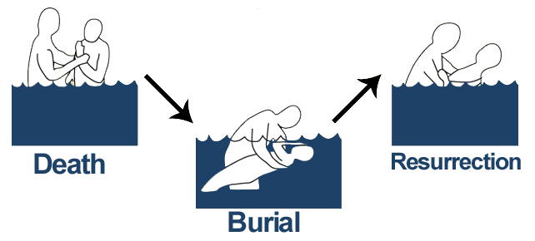
- Acts 2:38
38 Then Peter said unto them, Repent, and be baptized every one of you in the name of Jesus Christ for the remission of sins, and ye shall receive the gift of the Holy Ghost.
- Romans 6:3-4
3 Know ye not, that so many of us as were baptized into Jesus Christ were baptized into his death?
4 Therefore we are buried with him by baptism into death: that like as Christ was raised up from the dead by the glory of the Father, even so we also should walk in newness of life.
- Galatians 3:27
27 For as many of you as have been baptized into Christ have put on Christ.

8. BENEFITS OF SALVATION
- HEAVENLY HOME
- John 14:3
- 2 Corinthians 5:1
- Philippians 3:20
- ETERNAL LIFE WITH JESUS
  - Romans 6:23
  - 1 John 2:25
- FORGIVENESS OF SINS
  - Ephesians 1:7
- PEACE WITH GOD
  - Isaiah 26:3
  - Romans 5:1
  - Philippians 4:7
- ADOPTION INTO GOD’S FAMILY
  - John 1:12
- INDWELLING OF THE HOLY SPIRIT
  - Ephesians 1:13
- FREEDOM FROM THE POWER OF SIN
  - Romans 6:14
- HOPE OF GLORY
  - Colossians 1:27
- NEW IDENTITY IN CHRIST
  - 2 Corinthians 5:17
- ACCESS TO GOD THROUGH PRAYER
  - Hebrews 4:16
- FAMILY REUNIONS
  - 1 THESSALONIANS 4:14
  - LUKE 23:43
- ASSURANCE AND SECURITY
  - Romans 8:38-39

SCRIPTURES ON SALVATION

Psalms 3:8
⁸Salvation belongeth unto the LORD: thy blessing is upon thy people. Selah.

Psalms 37:39
³⁹But the salvation of the righteous is of the LORD: he is their strength in the time of trouble.

Psalms 62:1
Truly my soul waiteth upon God:
from him cometh my salvation.

Matthew 7:21
²¹Not every one that saith unto me, Lord, Lord, shall enter into the kingdom of heaven; but he that doeth the will of my Father which is in heaven.

Luke 5: 32
³²I came not to call the righteous, but sinners to repentance.

JOHN 3:16
¹⁶ For God so loved the world, that he gave his only begotten Son, that whosoever believeth in him should not perish, but have everlasting life.

John 14:6 –
⁶Jesus saith unto him, I am the way, the truth, and the life: no man cometh unto the Father, but by me.

Acts 4:12 - Neither is there salvation in any other: for there is none other name under heaven given among men, whereby we must be saved.

Acts 16:31
³¹And they said, Believe on the Lord Jesus Christ, and thou shalt be saved, and thy house.

Romans 10:9
⁹That if thou shalt confess with thy mouth the Lord Jesus, and shalt believe in thine heart that God hath raised him from the dead, thou shalt be saved.

Romans 10:10
¹⁰For with the heart man believeth unto righteousness; and with the mouth confession is made unto salvation.

EPHESIANS 2: 8-9
⁸ For by grace are ye saved through faith; and that not of yourselves: it is the gift of God:
⁹ Not of works, lest any man should boast.

The Bible is a story of how God has worked and is working in history to remedy SIN. The story began with Sin but ends with the Opportunity for the Hope of Eternal Life. (Unknown author)

JESUS IS GOD
1 Timothy 3:16
16 And without controversy great is the mystery of godliness: God was manifest in the flesh,
justified in the Spirit, seen of angels, preached unto the Gentiles,
believed on in the world, received up into glory.

There is only one true, supreme, GOD. The God of Abraham, Issac and Jacob. The God of the Holy Bible.

We believe in the Trinity of the three persons in one Godhead, not three Gods but rather one God with three distinct persons. A concept that only God can fully explain but He has revealed Himself to us through each, God the Father, the Son and the Holy Spirit.

God does not have a natural son. When we speak of God the Son or the Son of God we are referring to His divinity. The leaders of the people, kings, princes, judges, as holding authority from God, were called sons of God. It is a term used Daniel 3:25. It is a title expressing His divinity and authority.

The fact that Jesus (Yeshua or Joshua) is Yahweh (Lord) can be proved by comparing OT verses with the corresponding NT verses.

- Isaiah 40:3 speaks about preparing the way for the LORD (Yahweh). When we compare this verse with Mark 1:3 we readily see that Jesus is the LORD who had the way prepared for him by John the Baptist.

- In Joel 2:32a it says that whoever calls upon the Name of the LORD (Yahweh) will be saved. This verse is quoted by Peter in Acts 2:21, and by Paul in Romans 10:13. Both apostles are clearly referring to Jesus as the LORD.

- In Isaiah 6:1-10 we read about the marvelous vision that Isaiah had revealing the glory of the LORD (Yahweh). John tells us, in John 12:40-41, that this vision revealed the glory of Jesus.

- In Isaiah 44:6, Yahweh refers to himself as “the First and the Last”. In Revelation 1:8 and 17, Jesus similarly refers to himself as “the Alpha and the Omega” and “the First and the Last”.

- In Zechariah 12:10 the LORD (Yahweh) is speaking and says that, “they will look on Me whom they have pierced.”[ This is obviously Jesus speaking (Psalm 22:16; John 19:34). This passage from Zechariah appears again in Revelation 1:7b and is clearly about Jesus Christ.

GOD IN THE OLD TESTAMENT | JESUS’ REFERENCE TO HIMSELF IN THE NT
I AM (Exodus 3:14–15; Isaiah 48:12) | I AM (John 8:58)
The Shepherd (Psalm 23:1 | The Shepherd (John 10:11)
The Light (Psalm 27:1) | The Light (John 8:12)
The Rock (Psalm 18:2) | The Rock (Matthew 7:24)
Ruler of all (Isaiah 9:6 | Ruler of all (Matthew 28:18)
Judge of all nations (Joel 3:12 | Judge of all (John 5:22)
The Bridegroom (Isaiah 62:5; Hosea 2:16 | The Bridegroom (Matthew 25:1)
God’s Word never passes away (Isaiah 40:8) | Jesus’ words never pass away (Mark 13:31)
The Sower (Jeremiah 31:27; Ezekiel 36:9) | The Sower (Matthew 13:3–9)
First and the Last (Isaiah 48:12 | First and the Last (Revelation 1:17–18

https://www.gotquestions.org/is-Jesus-Yahweh.html

ONLY GOD CAN DO THE FOLLOWING SO HOW DOES JESUS?

- KNOW ALL THINGS
    - JOHN 21:17
17 He saith unto him the third time, Simon, son of Jonas, lovest thou me? Peter was grieved because he said unto him the third time, Lovest thou me? And he said unto him, Lord, thou knowest all things; thou knowest that I love thee. Jesus saith unto him, Feed my sheep.

    - JOHN 16:30
30 Now are we sure that thou knowest all things, and needest not that any man should ask thee: by this we believe that thou camest forth from God.

- KNOW ALL MEN
- JOHN 2:24
24 But Jesus did not commit himself unto them, because he knew all men,
- BE EVERYWHERE – PERPETUAL PRESENCE
- MATTHEW 28:20
20 Teaching them to observe all things whatsoever I have commanded you: and, lo, I am with you alway, even unto the end of the world. Amen.

- JOHN 14:23
23 Jesus answered and said unto him, If a man love me, he will keep my words: and my Father will love him, and we will come unto him, and make our abode with him.

- DWELL IN YOU
    - COLOSSIANS 1:27
27 To whom God would make known what is the riches of the glory of this mystery among the Gentiles; which is Christ in you, the hope of glory:

- BE OUR LORD AND MASTER
  - JUDE 1:4
4 For there are certain men crept in unawares, who were before of old ordained to this condemnation, ungodly men, turning the grace of our God into lasciviousness, and denying the only Lord God, and our Lord Jesus Christ.

- BE ETERNAL
  - MICAH 5:1-2
1 Now gather thyself in troops, O daughter of troops: he hath laid siege against us: they shall
smite the judge of Israel with a rod upon the cheek.
2 But thou, Bethlehem Ephratah, though thou be little among the thousands of Judah, yet out of
thee shall he come forth unto me that is to be ruler in Israel; whose goings forth have been from
of old, from everlasting.

- HEBREWS 13:8
8 Jesus Christ the same yesterday, and today, and forever.

- JOHN 8:58
58 Jesus said unto them, Verily, verily, I say unto you, Before Abraham was, I am.

- REVELATION 1:8
8 I am Alpha and Omega, the beginning and the ending, saith the Lord, which is, and which was, and which is to come, the Almighty.

- REVELATION 1:18
18 I am he that liveth, and was dead; and, behold, I am alive for evermore, Amen; and have the keys of hell and of death.

- HOW CAN HE RAISE HIMSELF FROM THE DEAD
    - JOHN 2:19-21
19 Jesus answered and said unto them, Destroy this temple, and in three days I will raise it up. ²⁰ Then said the Jews, Forty and six years was this temple in building, and wilt thou rear it up in three days?
21 But he spake of the temple of his body.

- HOW CAN JESUS CREATE ALL THINGS
- COLOSSIANS 1:16-17
16 For by him were all things created, that are in heaven, and that are in earth, visible and invisible, whether they be thrones, or dominions, or principalities, or powers: all things were created by him, and for him:
17 And He is before all things, and in Him all things consist.

- HOW CAN HE BE THE EXACT RADIANCE (REPRESENTATION) OF GOD
- HEBREWS 1:3
3 Who being the brightness of his glory, and the express image of his person, and upholding all things by the word of his power, when he had by himself purged our sins, sat down on the right hand of the Majesty on high;

- HOW CAN HE GIVE ETERNAL LIFE
- JOHN 10:27-28
27 My sheep hear my voice, and I know them, and they follow me:
28 And I give unto them eternal life; and they shall never perish, neither shall any man pluck them out of my hand.

https://www.carm.org/if-jesus-were-not-god-then-explain

HE IS CALLED THE HOLY ONE.
- ACTS 3:14
14 But ye denied the Holy One and the Just, and desired a murderer to be granted unto you;

- HOSEA 11:9
9 I will not execute the fierceness of mine anger, I will not return to destroy Ephraim: for I am God, and not man; the Holy One in the midst of thee: and I will not enter into the city.

THE OT IDENTIFIES JESUS AS GOD
- PSALMS 116:4
4 Then called I upon the name of the LORD; O LORD, I beseech thee, deliver my soul.
- “Call upon the name of the LORD” (Hebrew, YHWH, i.e., Psalm 116:4) used only of God on the OT and translated into Greek in the LXX as “Call upon the name of the LORD (greek, “KURIOS”) applied to Jesus in the NT (1 Cor. 1:2) if Jesus is not God in flesh?”
https://www.carm.org/if-jesus-were-not-god-then-explain
- ISAIAH 7:14
14 Therefore the Lord himself shall give you a sign; Behold, a virgin shall conceive, and bear a son, and shall call his name Immanuel

- ISAIAH 9:6
6 For unto us a child is born , unto us a son is given : and the government shall be upon hisshoulder: and his name shall be called Wonderful, Counsellor , The mighty God, The everlasting Father, The Prince of Peace.

- MATTHEW 1:22-23
22 Now all this was done, that it might be fulfilled which was spoken of the Lord
by the prophet, saying,
23 Behold, a virgin shall be with child,
And shall bring forth a son, and they shall call his name Emmanuel, which being
Interpreted is, God with us.

ANGELS PROCLAIMED HIM TO BE GOD
- Luke 2: 10-11
10 And the angel said unto them, Fear not: for, behold, I bring you good tidings of great joy,
which shall be to all people.
11 For unto you is born this day in the city of David a Saviour, which is Christ the Lord.

- Matt 28:5
5 And the angel answered and said unto the women, Fear not ye: for I know that ye seek Jesus, which was crucified.
DEMONS ACKNOWLEDGED HIM TO BE GOD
- Mark 1:23-27
23 And there was in their synagogue a man with an unclean spirit; and he cried out,
24 Saying, Let us alone; what have we to do with thee, thou Jesus of Nazareth? art thou come to destroy us? I know thee who thou art, the Holy One of God.
25 And Jesus rebuked him, saying, Hold thy peace, and come out of him.
26 And when the unclean spirit had torn him, and cried with a loud voice, he came out of him.
27 And they were all amazed, insomuch that they questioned among
themselves, saying, What thing is this? what new doctrine is this? for with authority commandeth he even the unclean spirits, and they do obey him.

- Matt 8: 29
29 And, behold , they cried out , saying , What have we to do with thee, Jesus, thou Son of God? art thou come hither to torment us before the time?

THOMAS CALLED HIM GOD
- John 20:28-29
28 And Thomas answered and said unto him, My Lord and my God.
29 Jesus saith unto him, Thomas, because thou hast seen me, thou hast believed : blessed are they that have not seen ,and yet have believed .

JOHN CALLED HIM GOD
- John 1:1
1 In the beginning was the Word, and the Word was with God, and the Word was God

- I John 5:20
20 And we know that the Son of God is come, and hath given us an understanding, that we may know him that is true, and we are in him that is true, even in his Son Jesus Christ. This is the true God, and eternal life.

PAUL CALLED HIM GOD
- Romans 9:5
5 Whose are the fathers, and of whom as concerning the flesh Christ came, who is over all,
God blessed forever. Amen.

- Colossians 2:9
9 For in him dwelleth all the fulness of the Godhead bodily.

HIS DISCIPLES CALLED HIM GOD
- Matthew 14:32-33:
32And when they climbed into the boat, the wind died down.
33Then those who were in the boat worshiped him, saying, ‘Truly you are the Son of God.’”

JUDE CALLED HIM GOD
- JUDE 25
25 To the only wise God our Saviour, [be] glory and majesty, dominion and power, both now and
ever. Amen

- JESUS HIMSELF SAID HE WAS GOD
- John 10:30
30 I and my Father are one.

- John 5:17-23
17 But Jesus answered them, My Father worketh hitherto , and I work .
18 Therefore the Jewssought the more to kill him, because he not only had broken the sabbath, but said also that God was his Father, making himself equal with God.
19 Then answered Jesus and said unto them,Verily, verily, I say unto you, The Son can do nothing of himself, but what he seeth the Father do :for what things soever he doeth , these also
doeth the Son likewise.
20 For the Father loveth the Son, and sheweth him all things that himself doeth : and he will shew him greater works than these, that ye may marvel .
21 For as the Father raiseth up the dead, and quickeneth them; evenso the Son quickeneth
whom he will .
22 For the Father judgeth no man, but hath committed all judgment unto the Son:
23 That all menshould honour the Son, even as they honour the Father.He that honoureth
not the Son honoureth not the Father which hath sent him.

- John 8:58-59
58 Jesus said unto them, Verily, verily, I say unto you, Before Abraham was, I Am.
59 Then took they up stones to cast at him: but Jesus hid himself , and went out of the temple going through the midst of them, and so passed by

- Ex. 3:14
14 And God said unto Moses, I AM THAT I AM : and he said , Thus shalt thou say unto the children of Israel, I AM hath sent me unto you

GOD CALLED HIM GOD
- Hebrews 1:8
8 But unto the Son he saith, Thy throne, O God, is for ever and ever: a sceptre of righteousness is the sceptre of thy kingdom.

THE WHOLE UNIVERSE SHALL ACCLAIM HIM GOD

- REV. 5:13
13 And every creature which is in heaven, and on the earth, and under the earth, and such asare in
the sea, and all that are in them, heard I saying , Blessing, and honour, and glory, and power, be unto him that sitteth upon the throne, and unto the Lamb for ever and ever.

- PHILIPPIANS 2:10-11
10 That at the name of Jesus every knee should bow, of things in heaven, and thingin earth,
and things under the earth; 11 And that every tongue should confess that Jesus Christ is Lord, to the glory of God the Father.

USEFUL RESOURCES

http://www.baptistbiblebelievers.com/OTStudies/MannersandCustomsInBibleLands1953.aspx

https://www.biblegateway.com

http://www.biblehub.com

http://www.biblestudytools.com

http://www.biblestudytools.com/history

http://timeline.biblehistory.com/home

http://www.bible-history.com/subcat.php?id=39

http://christianity.about.com/od/biblefactsandlists/a/History-Of-The-Bible.htm

http://biblicalstudies.org.uk/article_idioms.html

https://www.gotquestions.org

http://www.jewishencyclopedia.com

http://www.jewishvirtuallibrary.org

http://www.sacred-texts.com/index.htm

http://www.studylight.org

Strong’s Exhaustive Concordance

CLASS EVALUATION

Please complete and hand in to the presenter. It is not necessary to place your name.
Rate each criteria on a scale of 1-5.

YOUR NAME: (OPTIONAL)_____________________________________________________
PRESENTOR’S NAME: JOY KARANICK ROACH
SEMINAR NAME: GOING DEEPER IN THE WORD

CRITERIA | 1  VERY POOR | 2  FAIR | 3  GOOD | 4  ABOVE AVERAGE | 5  EXCELLENT
COURSE MATERIAL

COURSE CONTENT
VISUAL AIDS AND HANDOUTS
PRESENTOR
STYLE
PRESENTOR
CLARITY
PRESENTOR KNOWLEDGEABLE
PRESENTOR TIMELINESS
PRESENTOR RESPONSIVENESS
WOULD YOU LIKE TO HAVE ANOTHER SEMINAR

COMMENTS:

